


Prepare hot, cold and frozen dessert
D1.HCC.CL2.14
Trainee Manual


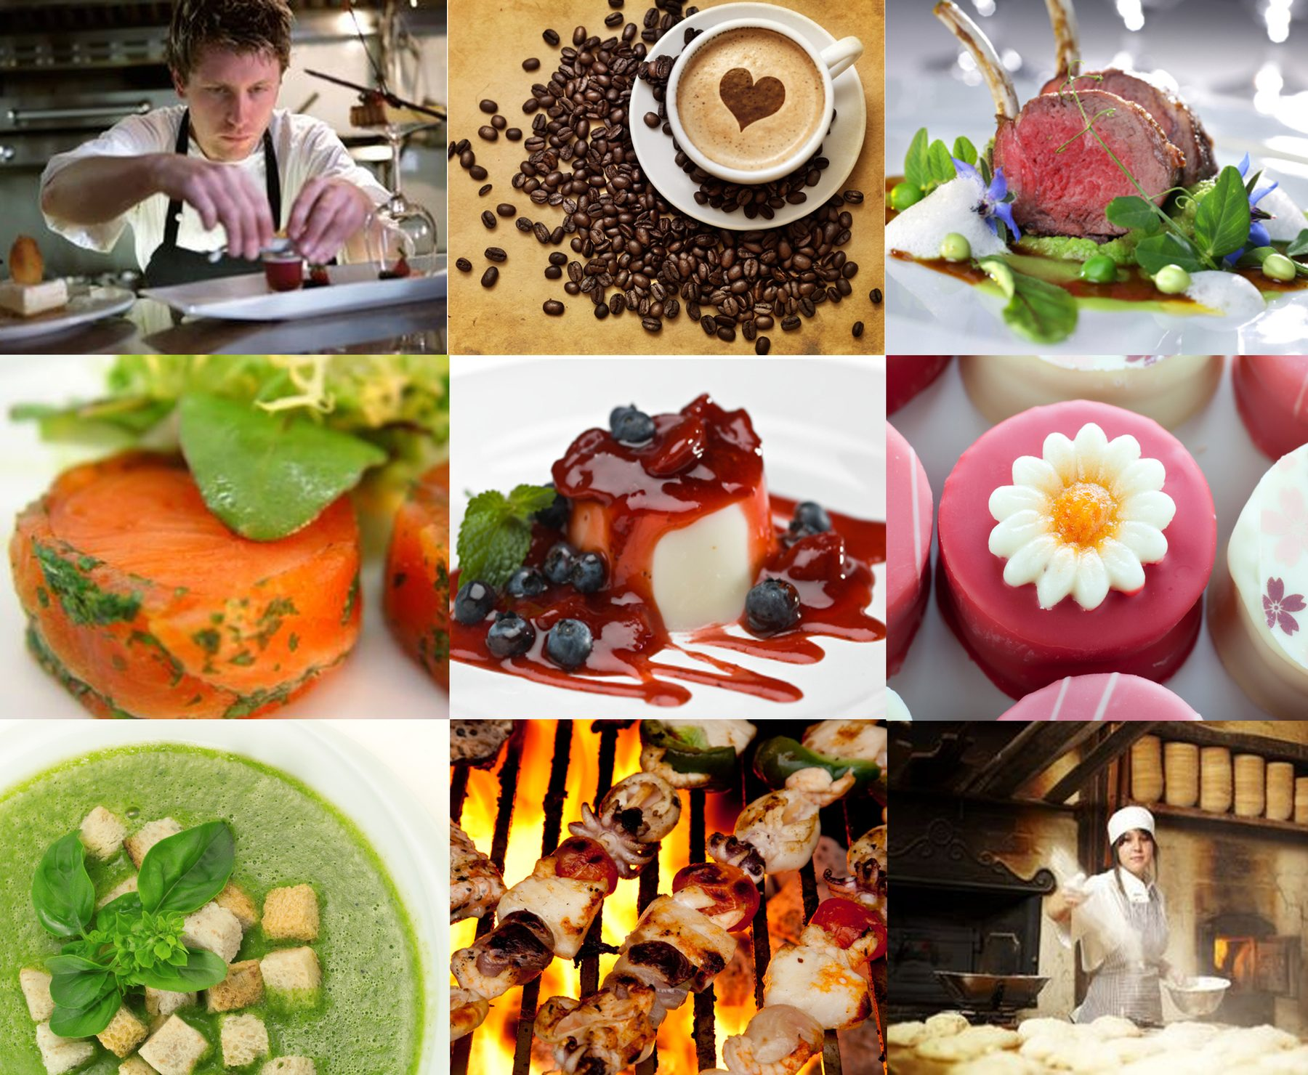



Prepare hot, cold and frozen dessert

D1.HCC.CL2.14

Trainee Manual





Project Base
William Angliss Institute of TAFE
555 La Trobe Street
Melbourne 3000 Victoria
Telephone: | (03) 9606 2111
Facsimile: | (03) 9670 1330
Acknowledgements
Project Director: | Wayne Crosbie
Chief Writer: | Alan Hickman
Subject Writer: | Garry Blackburn
Project Manager: | Alan Maguire
Editor: | Jim Irwin
DTP/Production: | Daniel Chee, Mai Vu, Jirayu Thangcharoensamut, Kaly Quach

The Association of Southeast Asian Nations (ASEAN) was established on 8 August 1967. The Member States of the Association are Brunei Darussalam, Cambodia, Indonesia, Lao PDR, Malaysia, Myanmar, Philippines, Singapore, Thailand and Viet Nam.
The ASEAN Secretariat is based in Jakarta, Indonesia.
General Information on ASEAN appears online at the ASEAN Website: www.asean.org.
All text is produced by William Angliss Institute of TAFE for the ASEAN Project on “Toolbox Development for Front Office, Food and Beverage Services and Food Production Divisions”.
This publication is supported by the Australian Government’s aid program through the ASEAN-Australia Development Cooperation Program Phase II (AADCP II).
Copyright: Association of Southeast Asian Nations (ASEAN) 2013.
All rights reserved.
Disclaimer
Every effort has been made to ensure that this publication is free from errors or omissions. However, you should conduct your own enquiries and seek professional advice before relying on any fact, statement or matter contained in this book. The ASEAN Secretariat and William Angliss Institute of TAFE are not responsible for any injury, loss or damage as a result of material included or omitted from this course. Information in this module is current at the time of publication. Time of publication is indicated in the date stamp at the bottom of each page.
Some images appearing in this resource have been purchased from stock photography suppliers Shutterstock and iStockphoto and other third party copyright owners and as such are non-transferable and non-exclusive. Clip arts, font images and illustrations used are from the Microsoft Office Clip Art and Media Library. Some images have been provided by and are the property of William Angliss Institute.
Additional images have been sourced from Flickr and SKC and are used under Creative Commons licence: http://creativecommons.org/licenses/by/2.0/deed.en
File name: TM_Prepare_hot_cold_&_frozen_desert_dishes_FN_090114





Table of contents
Introduction to trainee manual 1
Unit descriptor 3
Assessment matrix 5
Glossary 7
Introduction 11
Element 1: Prepare and produce a range of hot, cold and frozen desserts 15
Element 2: Prepare and store sweet sauces 55
Element 3: Prepare accompaniments, garnishes and decorations 65
Element 4: Store hot, cold and frozen desserts 71
Appendices: Recipes 77
Presentation of written work 113
Recommended reading 115
Trainee evaluation sheet 117
Trainee Self-Assessment Checklist 119

Introduction to trainee manual

To the Trainee
Congratulations on joining this course. This Trainee Manual is one part of a ‘toolbox’ which is a resource provided to trainees, trainers and assessors to help you become competent in various areas of your work.
The ‘toolbox’ consists of three elements:
- A Trainee Manual for you to read and study at home or in class
- A Trainer Guide with Power Point slides to help your Trainer explain the content of the training material and provide class activities to help with practice
- An Assessment Manual which provides your Assessor with oral and written questions and other assessment tasks to establish whether or not you have achieved competency.
The first thing you may notice is that this training program and the information you find in the Trainee Manual seems different to the textbooks you have used previously. This is because the method of instruction and examination is different. The method used is called Competency based training (CBT) and Competency based assessment (CBA). CBT and CBA is the training and assessment system chosen by ASEAN (Association of South-East Asian Nations) to train people to work in the tourism and hospitality industry throughout all the ASEAN member states.
What is the CBT and CBA system and why has it been adopted by ASEAN?
CBT is a way of training that concentrates on what a worker can do or is required to do at work. The aim is of the training is to enable trainees to perform tasks and duties at a standard expected by employers. CBT seeks to develop the skills, knowledge and attitudes (or recognise the ones the trainee already possesses) to achieve the required competency standard. ASEAN has adopted the CBT/CBA training system as it is able to produce the type of worker that industry is looking for and this therefore increases trainees chances of obtaining employment.
CBA involves collecting evidence and making a judgement of the extent to which a worker can perform his/her duties at the required competency standard. Where a trainee can already demonstrate a degree of competency, either due to prior training or work experience, a process of ‘Recognition of Prior Learning’ (RPL) is available to trainees to recognise this. Please speak to your trainer about RPL if you think this applies to you.
What is a competency standard?
Competency standards are descriptions of the skills and knowledge required to perform a task or activity at the level of a required standard.
242 competency standards for the tourism and hospitality industries throughout the ASEAN region have been developed to cover all the knowledge, skills and attitudes required to work in the following occupational areas:
- Housekeeping
- Food Production
- Food and Beverage Service
- Front Office
- Travel Agencies
- Tour Operations.
All of these competency standards are available for you to look at. In fact you will find a summary of each one at the beginning of each Trainee Manual under the heading ‘Unit Descriptor’. The unit descriptor describes the content of the unit you will be studying in the Trainee Manual and provides a table of contents which are divided up into ‘Elements’ and ‘Performance Criteria”. An element is a description of one aspect of what has to be achieved in the workplace. The ‘Performance Criteria’ below each element details the level of performance that needs to be demonstrated to be declared competent.
There are other components of the competency standard:
- Unit Title: statement about what is to be done in the workplace
- Unit Number: unique number identifying the particular competency
- Nominal hours: number of classroom or practical hours usually needed to complete the competency. We call them ‘nominal’ hours because they can vary e.g. sometimes it will take an individual less time to complete a unit of competency because he/she has prior knowledge or work experience in that area.
The final heading you will see before you start reading the Trainee Manual is the ‘Assessment Matrix’. Competency based assessment requires trainees to be assessed in at least 2 – 3 different ways, one of which must be practical. This section outlines three ways assessment can be carried out and includes work projects, written questions and oral questions. The matrix is designed to show you which performance criteria will be assessed and how they will be assessed. Your trainer and/or assessor may also use other assessment methods including ‘Observation Checklist’ and ‘Third Party Statement’. An observation checklist is a way of recording how you perform at work and a third party statement is a statement by a supervisor or employer about the degree of competence they believe you have achieved. This can be based on observing your workplace performance, inspecting your work or gaining feedback from fellow workers.
Your trainer and/or assessor may use other methods to assess you such as:
- Journals
- Oral presentations
- Role plays
- Log books
- Group projects
- Practical demonstrations.
Remember your trainer is there to help you succeed and become competent. Please feel free to ask him or her for more explanation of what you have just read and of what is expected from you and best wishes for your future studies and future career in tourism and hospitality.

Unit descriptor
Prepare hot, cold and frozen dessert
This unit deals with the skills and knowledge required to Prepare hot, cold and frozen dessert in a range of settings within the hotel and travel industries workplace context.
Unit Code:
D1.HCC.CL2.14
Nominal Hours:
55 hours

Element 1: Prepare and produce a range of hot, cold and frozen desserts
Performance Criteria
1.1 Select required commodities according to recipe and production requirements
1.2 Prepare a variety of hot desserts according to standard recipes and enterprise standards
1.3 Prepare a range of cold desserts according to standard recipes and enterprise standards
1.4 Prepare a range of frozen desserts according to standard recipes and enterprise standards
1.5 Use appropriate equipment to prepare hot, cold and frozen desserts
1.6 Use correct techniques to produce hot, cold and frozen desserts to enterprise standards
1.7 Produce hot, cold and frozen desserts to enterprise requirements and standards
1.8 Select correct cooking conditions for hot, cold and frozen desserts

Element 2: Prepare and store sweet sauces
Performance Criteria
2.1 Select required commodities according to recipe and production requirements
2.2 Prepare and produce a range of sweet sauces to enterprise requirements and standards
2.3 Store sweet sauces for use in a service period or for use at another occasion

Element 3: Prepare accompaniments, garnishes and decorations
Performance Criteria
3.1 Plan accompaniments, garnishes and decorations for desserts
3.2 Prepare accompaniments, garnishes and decorations for desserts

Element 4: Store hot, cold and frozen desserts
Performance Criteria
4.1 Store desserts at appropriate temperature and conditions to maintain quality, freshness and customer appeal
4.2 Pack down desserts to ensure taste, appearance and textures are maintained

Assessment matrix
Showing mapping of Performance Criteria against Work Projects, Written Questions and Oral Questions
The Assessment Matrix indicates three of the most common assessment activities your Assessor may use to assess your understanding of the content of this manual and your performance – Work Projects, Written Questions and Oral Questions. It also indicates where you can find the subject content related to these assessment activities in the Trainee Manual (i.e. under which element or performance criteria). As explained in the Introduction, however, the assessors are free to choose which assessment activities are most suitable to best capture evidence of competency as they deem appropriate for individual students.
 |  |  | Work Projects | Written Questions | Oral Questions
Element 1: Prepare and produce a range of hot, cold and frozen desserts
1.1 | Select required commodities according to recipe and production requirements |  | 1.1 | 1, 2, 3 | 1
1.2 | Prepare a variety of hot desserts according to standard recipes and enterprise standards |  | 1.2 | 4 | 2
1.3 | Prepare a range of cold desserts according to standard recipes and enterprise standards |  | 1.3 | 5 | 3
1.4 | Prepare a range of frozen desserts according to standard recipes and enterprise standards |  | 1.4 | 6, 7 | 4
1.5 | Use appropriate equipment to prepare hot, cold and frozen desserts |  | 1.5 | 8 | 5
1.6 | Use correct techniques to produce hot, cold and frozen desserts to enterprise standards |  | 1.2, 1.3  1.4 | 9 | 6
1.7 | Produce hot, cold and frozen desserts to enterprise requirements and standards |  | 1.2, 1.3  1.4 | 10 | 7
1.8 | Select correct cooking conditions for hot, cold and frozen desserts |  | 1.2, 1.3  1.4, 1.5 | 11, 12 | 8
Element 2: Prepare and store sweet sauces
2.1 |  | Select required commodities according to recipe and production requirements | 2.1 | 13, 14,  15, 16 | 9
2.2 |  | Prepare and produce a range of sweet sauces to enterprise requirements and standards | 2.2 | 17, 18 | 10
2.3 |  | Store sweet sauces for use in a service period or for use at another occasion | 2.3 | 19, 20 | 11
Element 3: Prepare accompaniments, garnishes and decorations
3.1 | Plan accompaniments, garnishes and decorations for desserts |  | 3.1 | 21 | 12
3.2 | Prepare accompaniments, garnishes and decorations for desserts |  | 3.2 | 22 | 13
Element 4: Store hot, cold and frozen desserts
4.1 |  | Store desserts at appropriate temperature and conditions to maintain quality, freshness and customer appeal | 4.1 | 23, 24, 25 | 14
4.2 |  | Pack down desserts to ensure taste, appearance and textures are maintained | 4.2 | 26, 27 | 15
Assessment Methods
The following methods may be used to assess competency for this unit:
- Observation of practical candidate performance
- Oral and written questions
- Third party reports completed by a supervisor
- Project and assignment work
- Sampling of dishes prepared by the student.

Glossary
Term | Explanation
Batter | Mixture of flour and liquids used to make pancakes or crepes and for coating for fried desserts like fritters
Blind Bake | Baking pastry to shape with no filling
Candied | Super saturated sugar solution is used to immerse product. Product absorbs sugar and when dry it is preserved by the sugar
Carmelise | Cooking sugar to above 156ºc at which point it begins to brown
Chemise | To line moulds with gelatine gel or sponge cake
Coagulate | Setting of protein, caused by heat
Confiture | Preserve fruits suspended in syrup or jelly
Coulis | Liquidised or pureed fruit sauce
Couverture | Pure chocolate
Creaming | Action of blending fat and sugar to incorporate air
Crimping | Squeezing edges of pastry to impart design
Curdling | Separation of liquid and solids, Emulsion has failed to form or has separated due to bad technique
Dariole mould | Angle sided mould wider at top than bottom
Dessert | Finale of a fine meal
Doyley | Paper lace mat used to present product, normally made of paper for desserts and pastry items
Dredge | To coat with flour or sugar
Enrobe | Covering completely with substance
Entremets | French word for sweet dishes
Folding | Method of gently blending of fragile ingredients
Fondant | Sugar mixture cooked to 114ºc and agitated while cooling forms which forms as white viscous product
Ganache | Chocolate and cream mixture used to enrobe product
Gelatine | Clear protein that is used set liquids. Can be purchased in powder or clear sheets
Gelatinisation | When water and starch are heated, the starch grains swell and absorb the liquid holding the liquid in suspension
Gliadin | Protein in flour that the elasticity
Gluten | Proteins glutenin and gliadin when hydrated bond together to form viscous substance called gluten.
Glutenin | Protein in flour that causes strength
Gum Arabic | Exudant from Acacia tree ground to powder and when rehydrated is used to impart glaze on confectionary products
Hulling | Removing calyx from strawberries
Humidity | Moisture in the air
Hydroscopic | Attracts moisture
Kneading | Manipulating a dough to develop the gluten and improve texture from sticky mass to smooth dough
Leavening | Incorporating air into dough by manipulating ingredients
Leavening agent | Ingredient that can cause gas within a dough or batter
Marcerate | Placing food in liquid so flavour is absorbed
Marinate | Flavour and tenderise food by placing into acidic liquid
Marshmallow | Confection or sweetmeat made from water, sugar and gelatine aerated and piped to shape. Many uses in pastries and desserts
Marzipan | Paste of sugar and ground blanched almonds
Masking | Coating of a cake or gateau with icing or coating inside of mould with gel
Nappe | To coat food with a sauce
Panada | A thickening agent made from a starch base
Pectin | Found mainly in citrus fruits and is used as a gelling agent
Pith | In skin wall of citrus fruits just under the white outer coating, the zest
Puree | Smooth fruit passed through a sieve
Rennet | Setting agent derived from the stomach of a calf, used in milk dessert 'junket'
Royal Icing | Blended eggwhite and fine icing sugar used to decorate cakes. Dries very hard.
Saccharometer | Instrument used to measure sugar density of liquid
Steep | Cover food in hot or cold liquid to soften, extract or induce flavour
Syneresis | Separation of liquid from a gel. Egg custard is overcooked and as protein shrinks, moisture is squeezed out
Syrup | Boiled sugar and water mixture
Texture | Internal structure of baked products cellular walls
Viscosity | Resistance of a liquid to movement or flow
Zest | Outer skin of citrus that contain volatile oils

Introduction

Interpretation of Standard recipes and Enterprise Standards
Standard recipes will yield a specific number of serves from any given recipe.
- Standard recipe is traditionally based at 10 serves per recipes
- Easier to multiply when larger numbers are required.
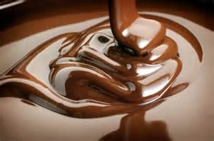
Enterprise standards are based on issues like:
- Is the cream real or imitation is being used?
- Is the chocolate bakers or couverture chocolate?
- Is the puff pastry made with shortening or with butter
- Is vanilla flavour imitation essence or real vanilla bean.
This can be the measure of Enterprise Standards.
Product will look exactly the same to the untrained eye.
Enterprises can have different standards under the same hotel name.

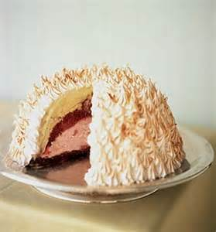
Reasons for desserts
Desserts are the grand finale of a meal. A dessert that is well presented and tastes delicious will leave a lasting impression of a great meal with the customer.
Traditionally desserts were prepared in a separate section of the kitchen by classically trained pastry chefs.
Some of the European specialty desserts that were often served included:
Charlotte Russe  Tarte Tartin  Crepe Suzette  Bombe Alaska  Sweet Dumplings | Apple Strudel  Baked Custard  Almond Pithivier  Pannacotta  Zabaglione.
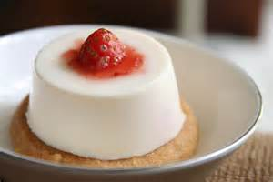
These classic desserts still appear on today’s menus but often with a modern twist such as
- Five spice Pannacotta
- Sour cherry and cream cheese strudel
- Rhubarb bread and butter pudding
- Roasted pear pithivier.
Today, with smaller kitchens that are unable to support the cost of specialised cooks, most desserts are either prepared by the chefs who have a wide range of skills but lack specialised training in this section or commercially.
The loss of skills within the smaller kitchens has led to an increase in manufactured dessert items used by the industry.
These small kitchens can demand a high quality, consistent product at an affordable cost that is often of higher quality than what they could produce for the same price.
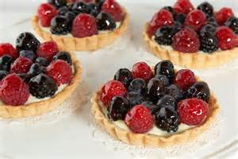
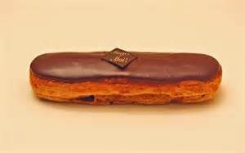
Products that are commonly produced and sold commercially may include:
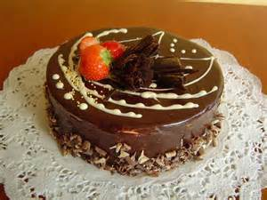
Gateaux Tortes Tarts
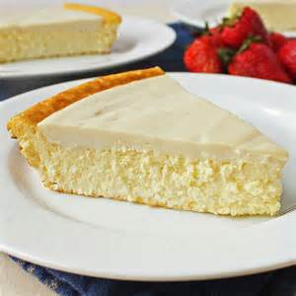
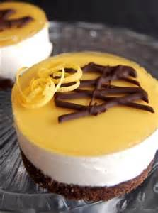
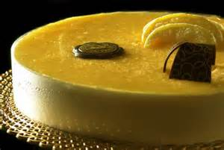

Mousses Bavarois Cheesecake
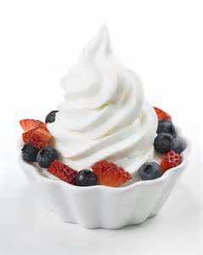
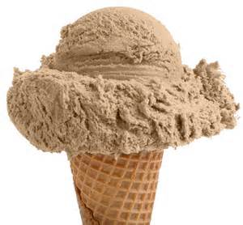
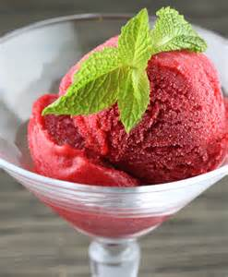

Ice creams Frozen yoghurt Sorbets

Within different establishments desserts may evolve from traditional classic, to modern, innovative dishes.
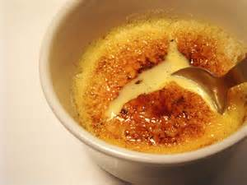
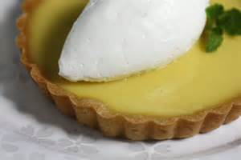

Classic crème brulee Lemon tart
Filling a baked pastry case with cooked crème brulee, caramelize the surface and finishing with a mound of macerated raspberries. This takes the creamy texture of the lemon tart which is replaced by the richness of the crème brulee. The acidity of the raspberries then balances this dish ensuring an all-round eating experience.
Today we commonly see the classic dishes reinvented. But first we must understand the basics, and then can we develop these classics with new ideas.

Categories of Desserts
The purpose of these categories is to assist menu planning.
Too many cream desserts or chocolate desserts will not create a well balanced dessert menu.
When a dessert from each category is included the dessert menu it will offer a greater choice to the customer.
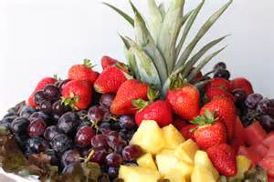
When you include a dessert from each category your dessert menu will offer a greater choice to the customer.
- Fruit – examples are fruit salad/platter, fruit in jelly, fruit crepe, summer pudding, roasted/grilled/poached fruit, baked crumbles
- Pastry – examples are tart (fruit, chocolate, lemon), mille feuille, pithivier, strudel, pies
- Batters and Dumplings – examples crepes, pancakes, fritters; fruit encased in batters both flat and aerated or just aerated batters in sauce
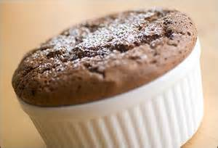
- Chocolate – examples are mousse, soufflé, tart, pudding, ice-cream, chocolate pot and Garnishes
- Frozen – examples are Ice-cream, Sorbet, Parfait, semifreddo, granita
- Cream – examples are Mousses, Pannacotta, Tira Mi Su, Trifle, Bavarois
- Baked Custards – Crème Caramel, Bread and Butter pudding and Crème Brulee
- Pudding – examples are steamed (chocolate and almond or self-saucing, Christmas fruit and suet), baked (clafoutis and fruit grunts)
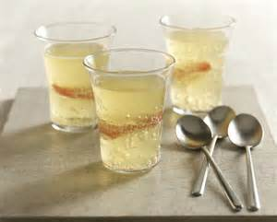
- Soufflé – these can be hot or cold and can be flavoured with fruit, chocolate, coffee, nuts, etc.
- Jelly – champagne, apple cider, elderflower, etc.
- Sauces – Chocolate, Caramel, Anglaise, Butter, Custards and Fruit Coulis.
In order for us to be able to produce these desserts, we need to understand how our ingredients work.
Within the pastry kitchen, eggs, sugar and flour are invaluable and without them, we couldn’t produce desserts.
In the following pages, the basic ingredients used for dessert production are explained in detail, giving varieties available, their various functions for dessert production and where appropriate, advice as to when one product is superior to another for a certain application.

Element 1:
Prepare and produce a range of hot, cold and frozen desserts

1.1 Select required commodities according to recipe and production requirements

Commodities
Sugars
Sugar is used in dessert production to:
- Add sweetness and flavour
- Create tenderness and fineness of texture, partly by weakening the gluten structure
- Give crust colour
- Increase keeping qualities by retaining moisture (it is a humectant)
- Act as a creaming agents with fats and as foaming agents with eggs
- Provide food for yeast
- To preserve.
Refined sugars are classified by the size of the grains.
Caster Sugar in finer than regular granulated sugar. This sugar supports higher quantities of fat and dissolves relatively quickly into doughs and batters.
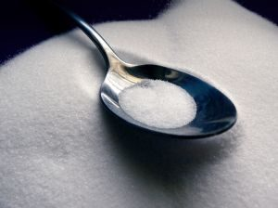
Caster sugar is the premium sugar to use in production of quality desserts and pastries.
Regular Granulated Sugar also known as table sugar or A1 is the most commonly known sugar. It has a coarse grain. In production the coarse grains leave undissolved grains, even after long mixing. After baking these show up as dark spots on crusts, irregular texture and syrupy spots. Coarse sugars are less refined and result in clearer syrup
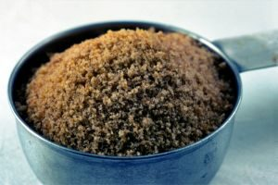
Brown Sugar contains 85 – 92 % sucrose and varying amounts of caramel, molasses and other impurities. Darker grades contain more of these impurities. Brown sugar is regular cane sugar that has not been completely refined
Demerara Sugar is also known as raw sugar. These straw coloured granules are produced from cane juice (90% sucrose). They are used in some baked goods and hot beverages.
Icing Sugar also known as confectioners’ sugar is sugar ground to a fine powder.
Soft Icing Mixture is icing sugar mixed with a small amount of starch (3 %) to prevent caking. It is also available in a pure form without this anti-caking starch.
Invert Sugar is a product of sugar refining. It is chemically processed heavy syrup where a sucrose solution is heated with an acid.
The sucrose breaks down into two simple sugars, dextrose and levulose:
DEXTROSE + LEVULOSE = INVERT SUGAR
(Equal parts)
Invert sugar is 30 % sweeter than sucrose.
Invert sugar resists crystallisation, promoting smoothness in candies, icings and syrups. It also holds moisture especially well, retaining freshness and moisture in products.
Molasses is concentrated sugar cane juice. It contains large amounts of sucrose and other sugars including invert sugar. It also contains acids, moisture and other constituents that give it flavour and colour. Darker grades are stronger in flavour and contain less sugar than lighter grades. Molasses retains moisture in baked goods, prolonging their freshness.
Corn Syrup is a liquid sweetener consisting of water, a vegetable gum called dextrin and various sugars, primarily dextrose, also called glucose. Corn syrup is made by converting cornstarch into simpler compounds through the use of enzymes. Corn syrup aids in retaining moisture and is used in some icings, sweets, and sugar boiling. It keeps other sugars from recrystallising. It is added to marzipan to improve elasticity. It has a mild flavour and is not as sweet as sucrose
Glucose Syrup is a viscous, colourless syrup (44˚ Baume). Glucose has a stabilising effect to help prevent re-crystallisation when sugar is boiled to high temperatures e.g. Cast, pulled and blown sugar making the boiled sugar more elastic. It is also used in cakes and biscuits. Glucose should not be stored at temperatures above 20ºC because it will change in colour. Glucose can be replaced with light corn syrup.
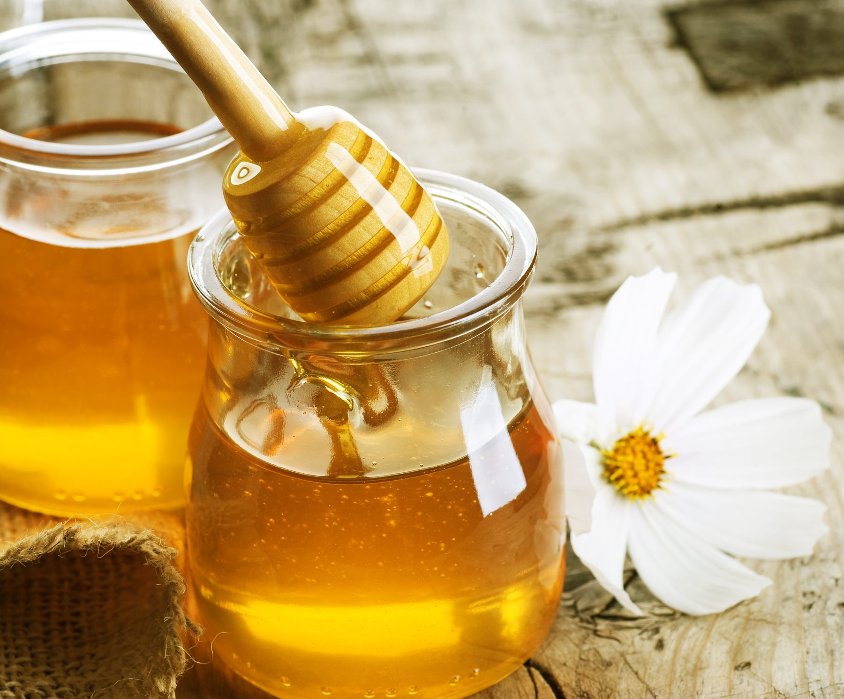
Honey was the first sugar to be used by man. It is the nectar collected from bees and deposited in their honeycomb. Nectar contains about 80% water and 20% sugar together with essential oils and aromatic compounds that are responsible for the bouquet of honey, the flavour varying from the flowers from which the nectar was gathered.
The darker the colour of the honey the stronger its flavour; it is a natural sugar syrup consisting largely of glucose, fructose and other compounds that give it is flavours. Flavour is the main reason for using honey.
Honey contains invert sugar which helps retain moisture in baked goods and gives a soft chewy texture to cakes and cookies, and is baked at a lower temperature so the invert sugars can caramelise.
Honey contains acid which enables it to be used with baking soda as a leavening.

Honey is available as:
- Comb honey – still in its waxy capsules
- Chunk honey – contains both the filtered extracted honey and a piece of honeycomb
- Extracted honey – most familiar for cooking and table use
- Whipped or spun honey – extracted honey that is processed using controlled crystallisation and which has fine easily spreadable crystals.

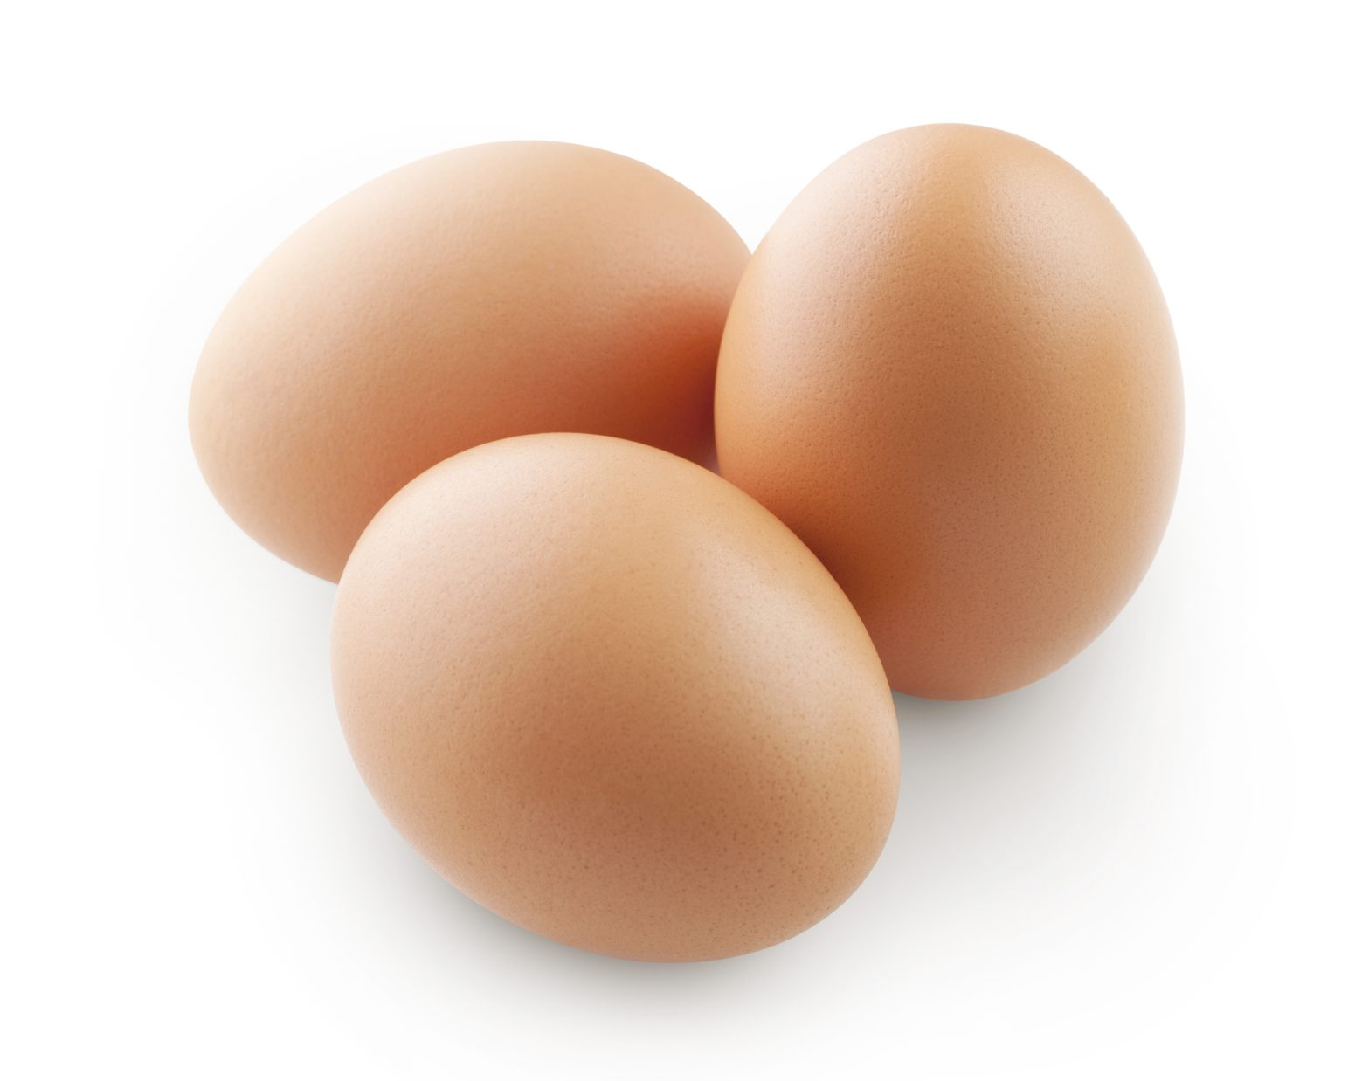
Eggs
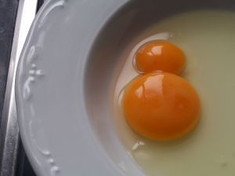
The Makeup of an Egg
The egg is made up of five main sections
1. The shell 12%
Consists mainly of calcium carbonate, is a hard protective porous covering containing nearly 8000 minute holes through which gases and water vapour can penetrate and escape.
Commercially eggshells are washed and sanitised to remove dirt and reduce the likelihood of salmonella contamination. They are also coated with mineral oil to delay moisture loss.
The eggshell colour can be either brown or white depending on the breed of the hen, having no effect on the flavour, nutrition or functionality of eggs.
2. The shell membrane and air pocket
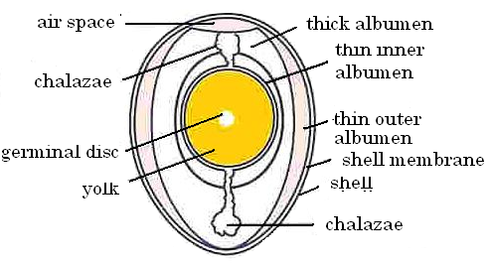
Eggs contain two protective membranes between the shell and the white. This membrane acts as a barrier against bacteria. The two layers are separated by the air pocket.
Soon after an egg is laid, an air pocket forms between the membranes at the eggs larger end.
As the egg ages, loses moisture and shrinks, the air pocket increases in size.
3. The layered albumen (eggwhite) including the chalazae 58%
Eggwhites other than small amounts of mineral ash and glucose consist entirely of protein (10 %) and water (9.0 %). It has very little flavour and colour.
There are two layers, one thick and the other thin.
As the egg ages the thick albumen begins to thin, losing its ability to form foams that are edible.
The chalazae are twisted white cords, which hold the yolk in the centre of the egg.
4. The yolk 29 %
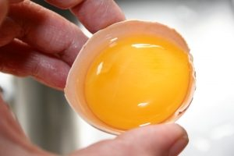
Egg yolks are about ½ moisture and ½ yolks solids. As eggs age, yolks pick up moisture from the white, resulting in the yolk flattening when cracked onto a smooth surface.
The solids in egg yolks consist of proteins, fats and emulsifiers with small amounts of mineral ash and yellow – orange carotenoids. These proteins are not the same as those of egg whites.
Many egg yolk proteins are considered lipoproteins because they are bound to fats and emulsifiers which are lipids.
Egg yolks contain lecithin which is a complex mixture of emulsifying lipids, containing fatty acids that are attracted to fats and oils.
Lecithin is bound by lipoproteins which bond to both water and oil allowing them to bind ingredients together like cake batters and mayonnaise.
Egg yolk colour and flavour is affected by the hen’s feed. The more carotenoids in the feed, the more yellow – orange the yolk.
5. The germinal disc
Can been seen as a very small spot on the centre of the yolks surface, and from which the chicken develops in an egg that has been fertilised for hatching.

Functions of Eggs for Dessert Production
Thicken | When heated egg coagulates and holds liquid in a suspension
Bind | When wet the food items stick together. When cooked, the egg sets and keeps the food together
Glaze | Beaten egg gives a shiny appearance
Aerate | When whipped the egg traps millions of tiny air cells within itself  Air bubbles help to raise other ingredients
Emulsify | Yolks can bind together to un-mixable ingredients
Clarify | Whites used to clarify stocks
Enrich | Adds flavour and nutrition

Dairy Products
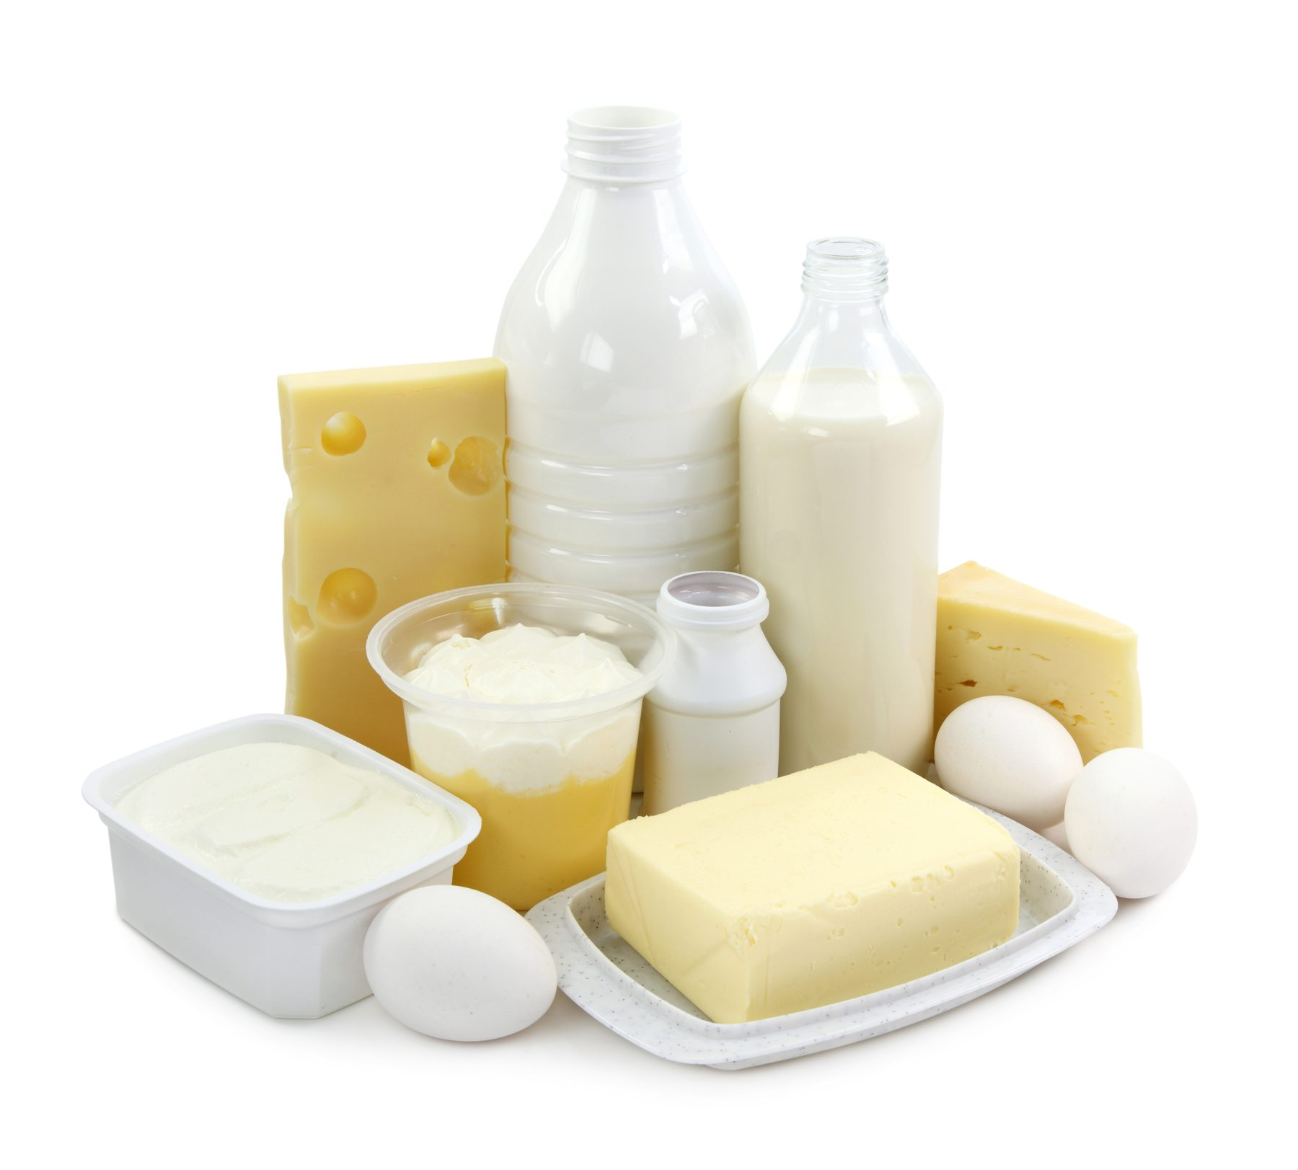
Dairy products are used extensively in the dessert section of the kitchen.
They include milk, buttermilk, cream, yoghurt, crème fraiche, mascarpone and butter.
Unsalted butter is recommended for pastry items, allowing you to control the salt content of the final product.
Storage and handling
Fluid milk and reconstituted dry milk products spoil easily. Bacteria multiply and produce acids and ‘off’ flavours, souring the milk.
While it is usually not harmful, soured milk should be discarded.
Beyond bacterial spoilage, the flavour of milk is highly susceptible to other changes, either absorbing aromas or from chemical reactions that occur from excessive heat or light. Irrespective of the many types of fresh milk, butter, cream, yoghurt and buttermilk, they must always be stored in the cool room under 5º C.
They should remain in the cartons they are purchased in and kept firmly closed.
Quality/ Shelf life
All dairy foods should be bought and used as quickly as possible because their storage life is limited.
The ‘use by date’ on the container the food is purchased in should be strictly adhered to.
Pasteurized whole milk has a shelf life of about two weeks when stored under 4 °C.
The actual shelf life depends on many factors, the main one being how well the product has been stored.
Always smell and taste dairy products before use.
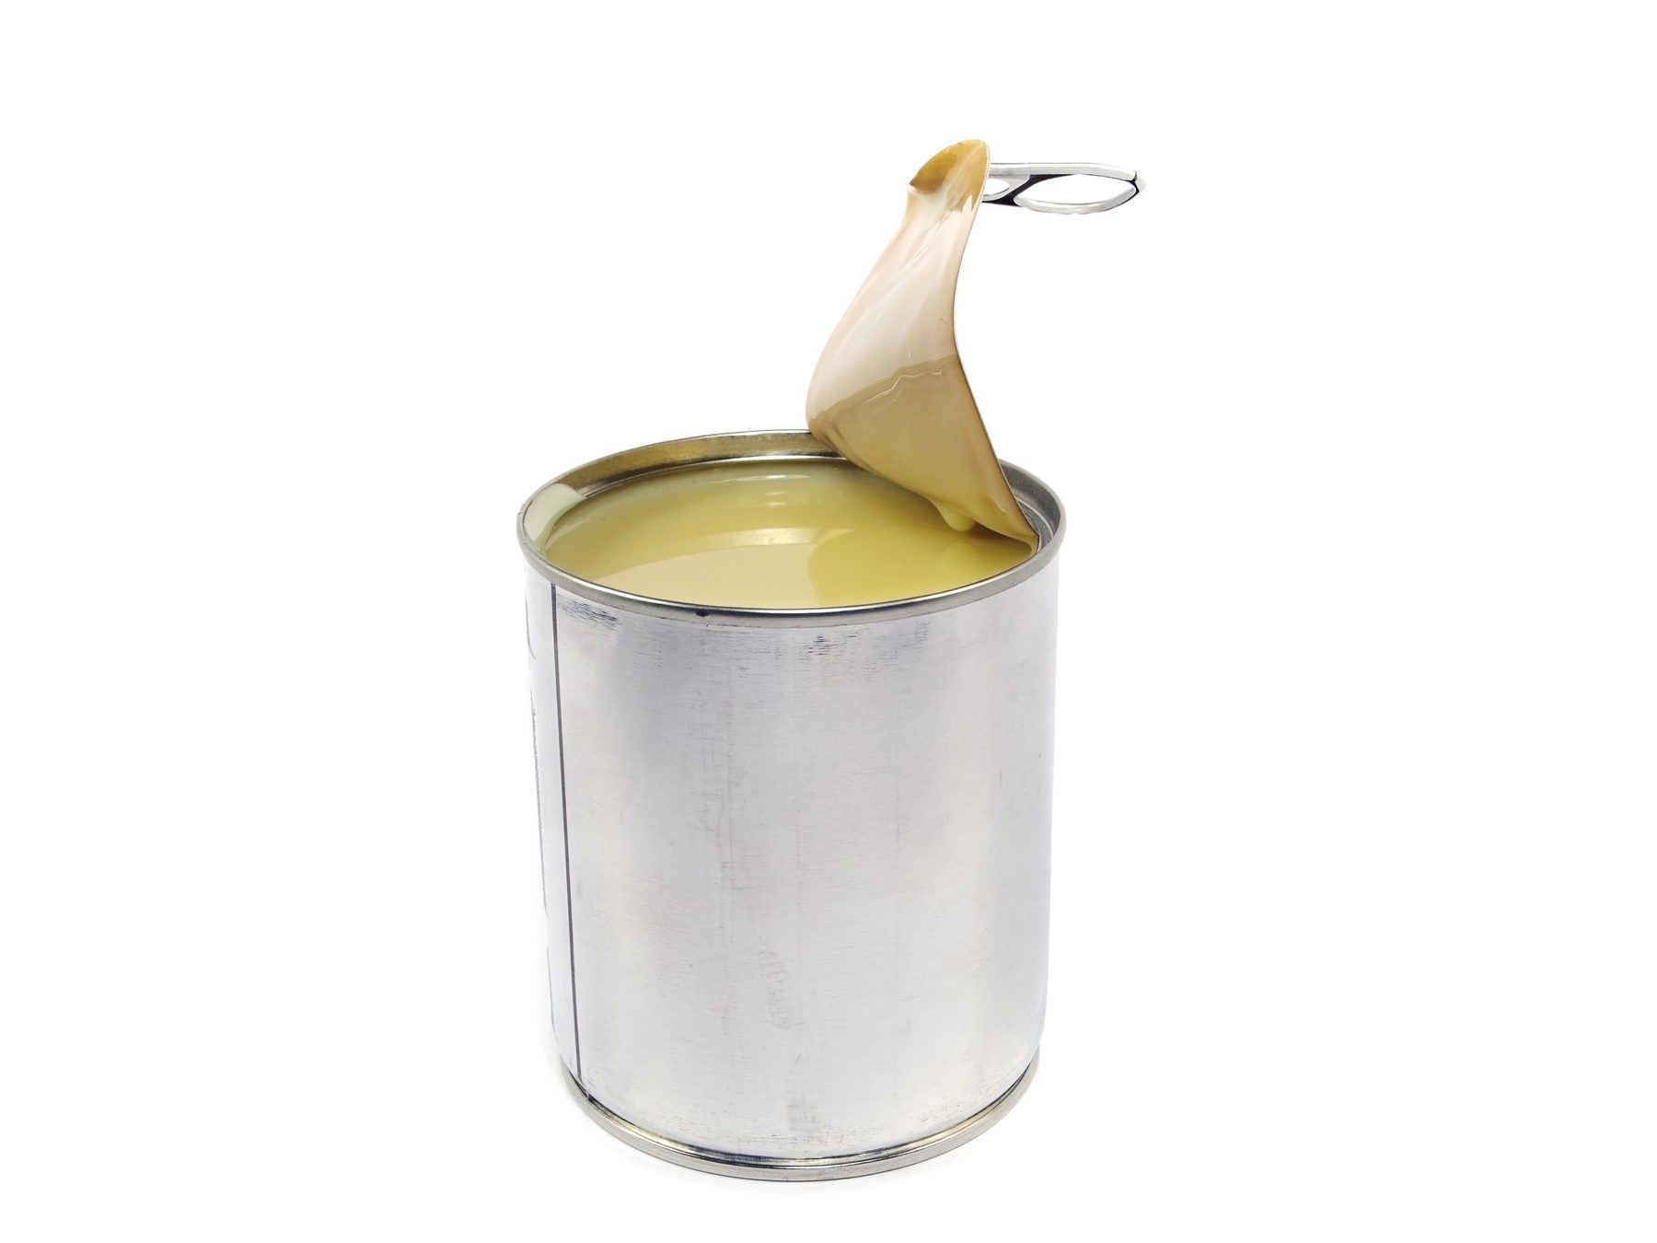
While cultured dairy products like yoghurt, buttermilk and sour cream have an extended shelf life, their acid content continues to increase over time.
Their flavour gradually becomes stronger, sharper and more pronounced. Whole dry milk contains milk fat that oxidizes to a rancid off flavour. It has a maximum shelf life of only six months, even when stored under ideal conditions.
Canned evaporated and sweetened condensed milk do not spoil even after several years, if kept unopened. Over time, however, they will darken, develop stronger flavours and change in consistency. Once opened, evaporated milk requires refrigeration, and is best to do the same with condensed milk as well.

Uses
Milk may form the foundation of many dishes irrespective if it is whole, skim or fat reduced, long life, evaporated, condensed or even powdered.
These dishes may include panna cotta, ice-cream, bavarois, brulee and baked custards. Milk is often used in cakes to thin the cake batter and create steam during the baking process, acting as a raising agent.
Buttermilk really is the ‘baker’s best friend’, it produces very light, delicious results in scones, pancakes, pikelets muffins etc.
Buttermilk has a fresh, slightly sharp, acid flavour and is used to counteract the bitter, soapy alkaline flavour, bicarbonate of soda leaves in many baked goods, e.g. banana cake.
Cream is the fat component of milk and varies enormously in richness, texture, and lusciousness.
Clotted cream is the thickest cream is at 55% fat followed by
Pure Cream at 48% fat.
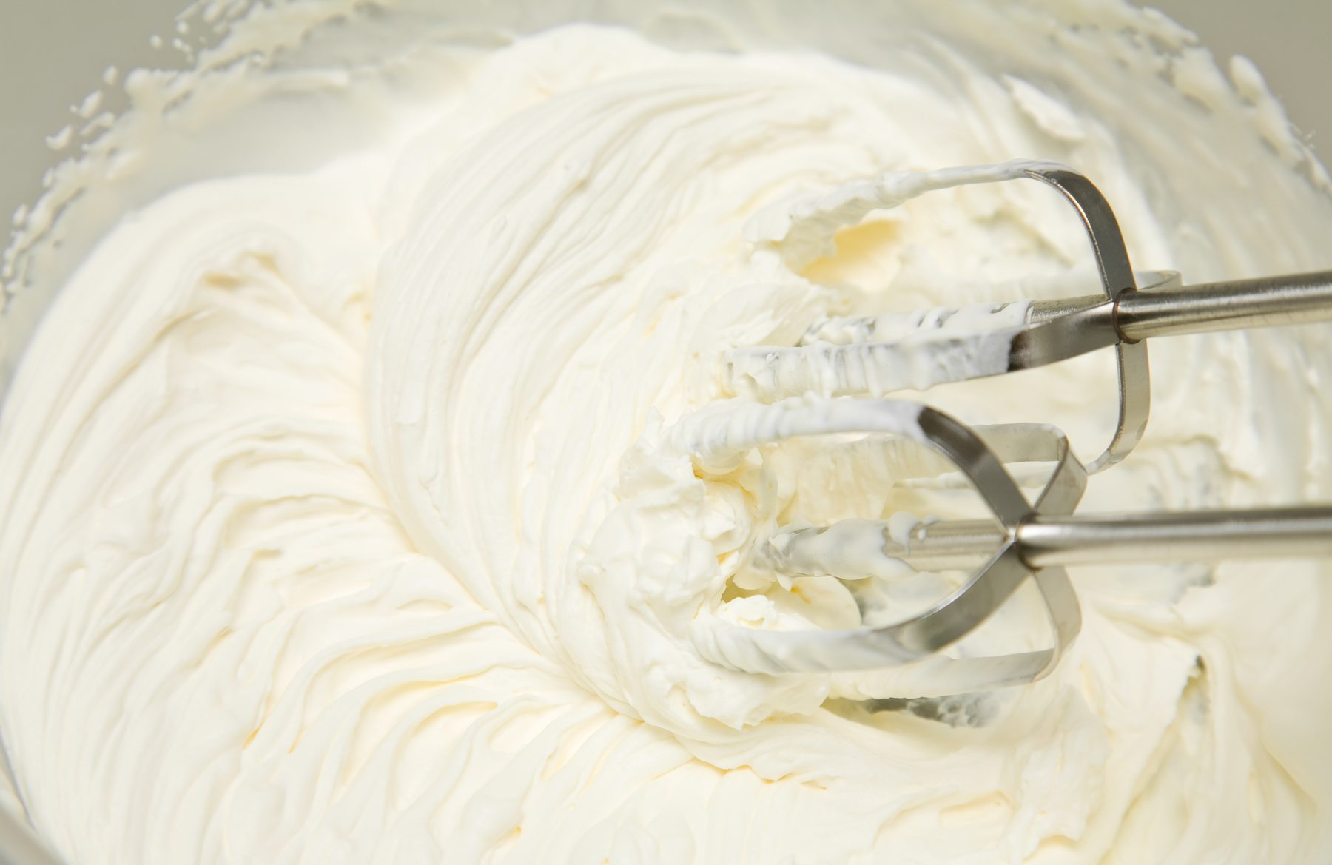
Pure cream and clotted cream may be served in dollop form accompanying berry fruits, scones etc. These creams do not aerate when whipped.
Thickened cream is 35% fat content. This cream may be whipped to trap air because it contains a gelling agent, ‘vegetable gum’, gelatine has also been used but has been replaced to appeal to a broader market.
The vegetable gum traps the air the air as the cream is whipped. As the cream stands the air will escape and the cream will ‘fall’, you may need to re-whip before using to hold shape.
Chilled thickened cream whips until it stands in peaks; there are soft peaks to fold into mousses, bavarois, and firm peaks for piping rosettes of cream on to a gateau.
The over whipping of cream will result in the product “splitting” (separation of the fat and water). Cream with a high fat content is more susceptible to this occurring.
Thickened cream needs to be kept chilled @ 4ºC until required to be whipped.
The warmer the cream, the greater the possibility of it ‘splitting’.
Reduced and light cream ranges from 25% - 18% fat and it will not whip because there is insufficient fat to trap air bubbles and thicken it. It is used as a pouring cream; it can replace milk in desserts to enrich them and is useful for people on fat reduced diets.
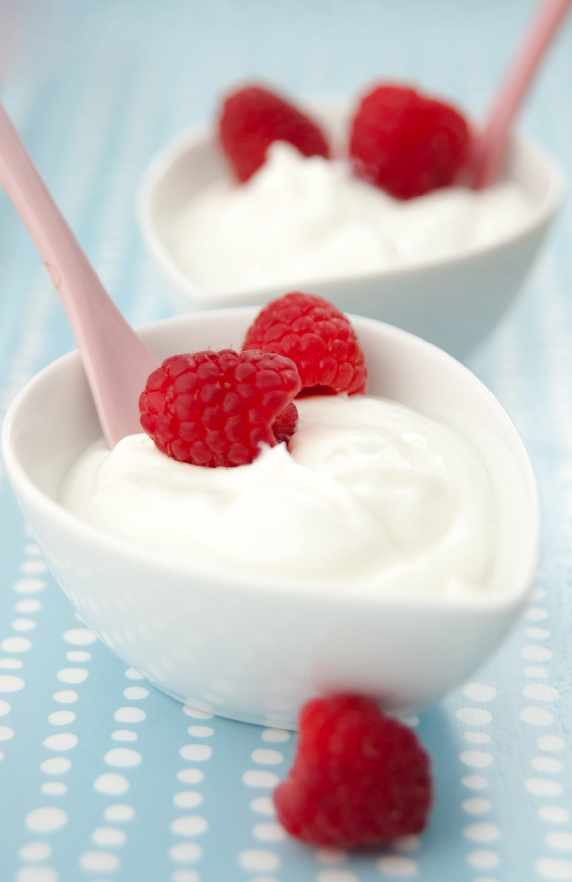
Yoghurt is a very healthy alternative to cream. It has many health properties as it contains a culture e.g. lactobacillus acidophilus and usually contains very little saturated fat. It may be used in a yoghurt based bavarois, sorbet, Panna cotta, ice-cream or as a cream substitute.
Yoghurt is available plain, flavoured or frozen.

Crème Fraiche
In France this is standard fresh French cream. However in Australia it contains a culture. The cream is naturally thick due to lactic acid bacteria in it which also produces a nutty flavour. Crème fraiche has a butter fat content of approx. 35% fat. The higher fat content makes it ideal for cooking; it may be used in some sauces without the risk of separating.
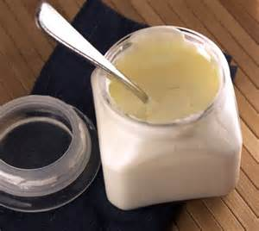
You may make your own crème fraiche by mixing and gently heating together 2 parts whipping cream with one part sour cream. Heat it slowly to blood temperature; do not boil. As it thickens, remove from heat and pour into a clean bowl. Leave to ripen at room temperature for approx. 8 hours then cover and store in the cool room.
Crème fraiche is often served as a dollop form with fresh sweetened berries.
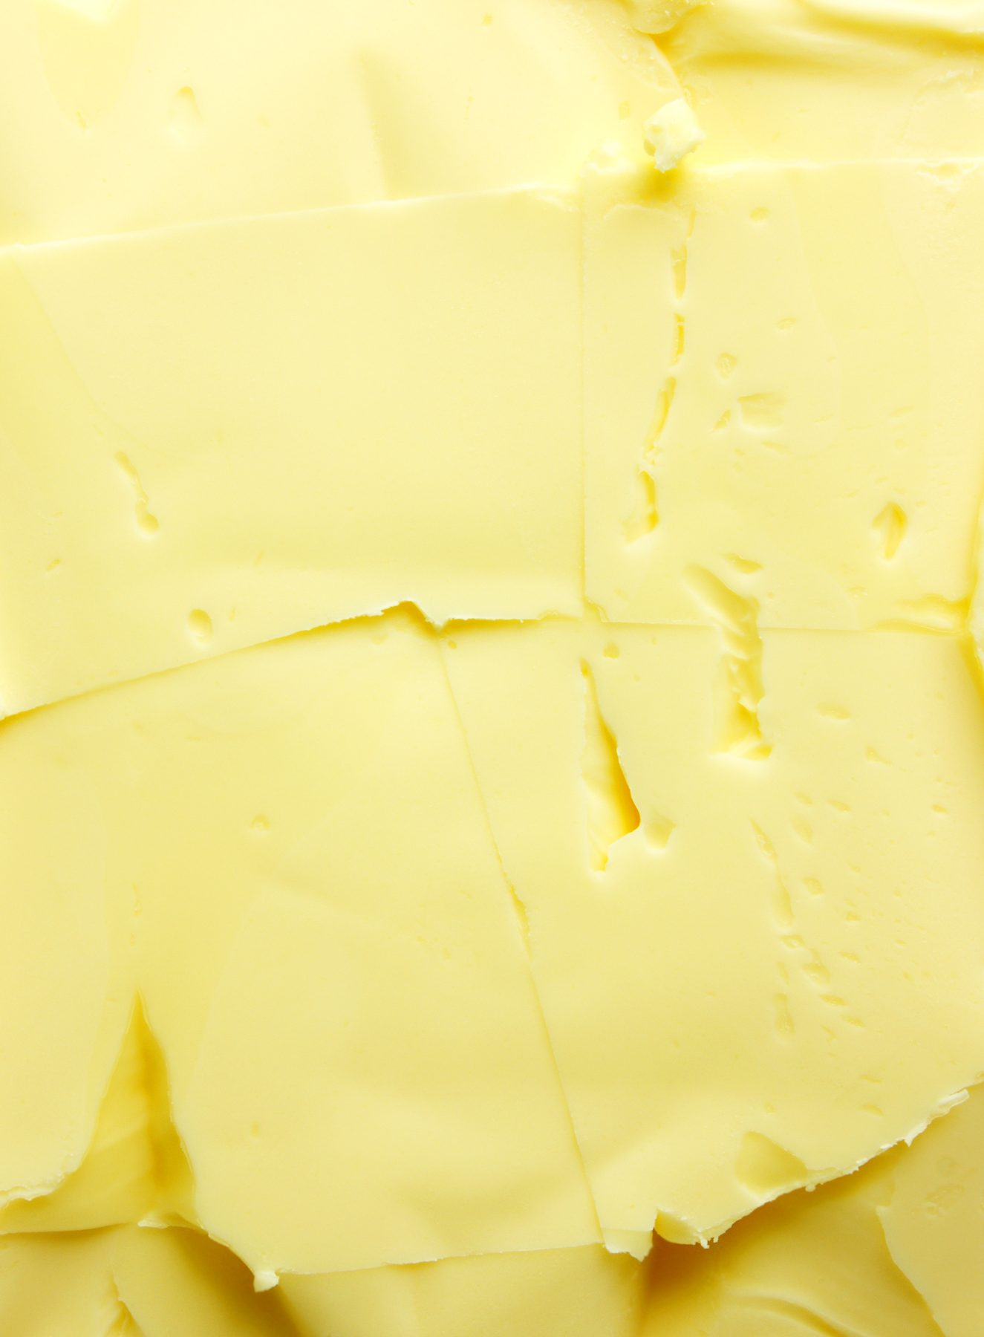
Butters
Butters are available salted or unsalted. Unsalted is the preferred choice because the cook/baker may add salt accurately and have greater control over the salt content. It has a much sweeter and more pleasant flavour than salted butter. (Salt was added to butter originally as a preservative).
Cultured European butter, like yoghurt, has a culture added to it. (Lactic bacteria culture) this is allowed to develop and ripen within the cream before it is churned into butter.
Butter is composed mostly of fat, some water, protein, simple sugars and either salt or culture.
Butter’s main use in baking is to trap air with sugar during the creaming process this gives lightness as an example cake making.
It also gives superior flavour, and colour and richness.
In contrast to cake making, butter is used in puff pastry production to allow for air to be trapped between layers of pastry and butter, resulting in light, crisp pastry layers.
Butter also aids tenderness to many baked goods e.g. sweet short crust pastry by coating the gluten strands in the pastry and retarding their development.
Butter maybe added to sauces to give richness and sheen, e.g. butterscotch sauce.
Butter is also used in batters to enhance flavour, tenderness and to help prevent the batter from sticking during the production of pancakes, crepes, etc.
Sometimes butter may be used as a lubricant. This is to help prevent baked goods adhering to their tins during the baking process.
Butter is best clarified for this purpose, e.g. phyllo pastry, strudel and sponge cakes.

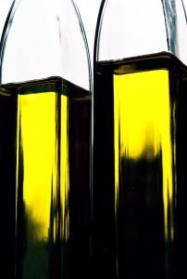
Oils
Oil is often used in baked goods as a healthy alternative to butter.
This results in a moister product which lengthens their shelf life, e.g. banana cake, carrot cake and sauternes and olive oil cake.
Many delicately flavoured oils e.g. almond oil may also be used for lubrication purposes.
One of the benefits of this, is it leaves the baked goods/dessert with sheen (butter and cheap baking fats set when cold and leave a dull greasy surface.
Sprays, e.g. non-stick canola oil cooking sprays are very convenient to use because it is easier to spray a fancy cake form than to brush with clarified butter.
However, these products are expensive and extremely flammable.
Storage
Both oils and sprays should be kept in very dry cool conditions away from uv light and warmth which will facilitate rancidity especially in oils.
Oils are best kept in airtight, coloured glass containers.
Note: Spray oils should not be used on non-stick surfaces and the chemical propellant has a detrimental effect on the surface coating.

Cheeses Commonly Used In Desserts
Bakers Cheese
A fresh (unripened) cheese with a low fat content, it is similar to cottage cheese, but it does not have curds and its flavour is a bit sourer. Baker’s cheese is used in cheesecakes and cheese fillings for pastries. It can be frozen.
Cottage Cheese
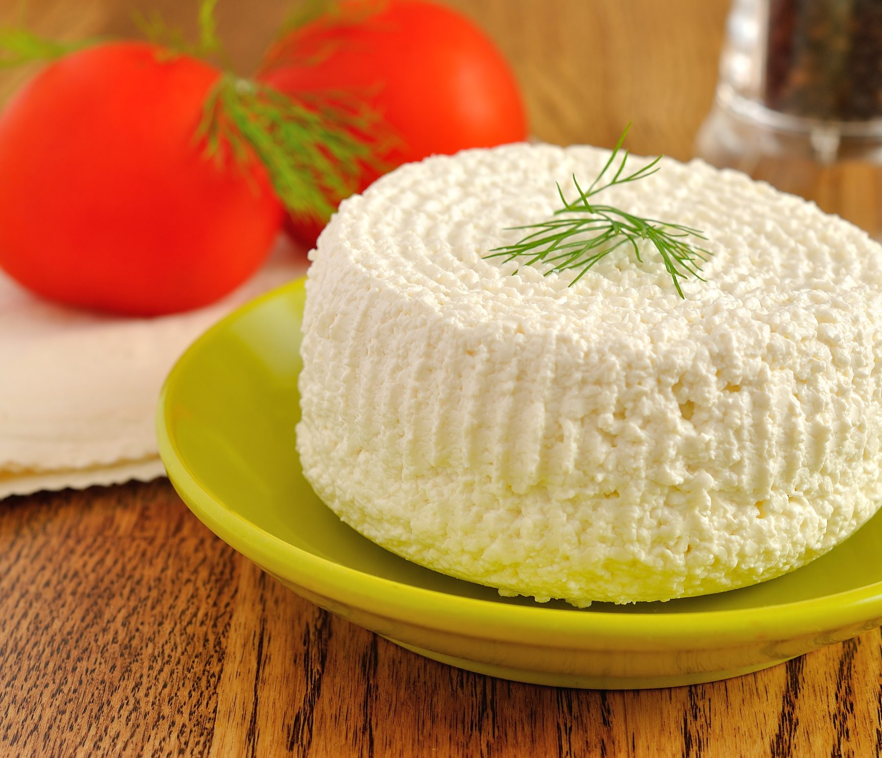
It is a lumpy, soft white cheese that can be purchased with small or large curds. It is often made with skimmed pasteurized cow’s milk. It can be used as a low fat alternative to cream cheese as well as for pancake and crepe fillings. It is also known as curd cheese.
Quark is a fresh dairy product loosely classified as a cheese. It originates from Austria and Germany and is a cross between yoghurt and cottage cheese.
Ricotta is from Italy. The word means re-cooked and its origins are in Rome and connected to the making of Romano and Mozzarella. Ricotta was first made from the whey that was left after the curds from these cheeses had been strained. Until about a century ago, this whey was discarded. At that time it was discovered that he protein rich whey would itself form curds if it were reheated. That product, after draining, was named ‘ricotta’. Ricotta is now produced commercially starting with whole milk rather than whey. Italian ricotta is primarily made from sheep’s milk or water buffalo milk and is more flavourful than the American version made from cow’s milk.

Cream Cheese
Has a mildly tangy, spreadable cheese with a smooth, creamy texture. This soft, unripened cheese is made from cow’s milk cultured with bacteria. It is a popular ingredient for many types of cheesecakes, pastry doughs, tarts and cookies.
Goats Milk Cheese
Known as Chèvre in French, goat’s milk cheese can range in texture from very dry and crumbly to moist and creamy. There are also fresh and ripened varieties.
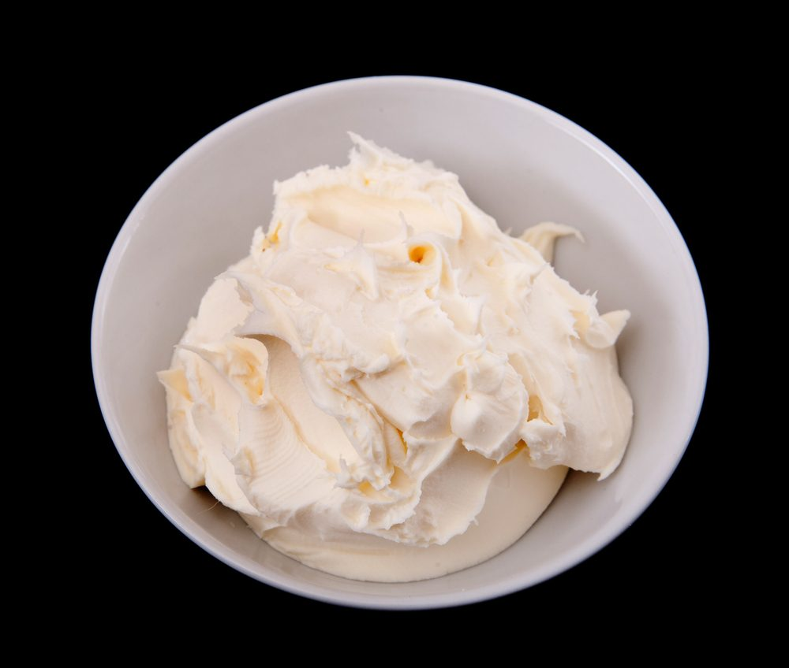
Mascarpone
This product is traditionally a triple cream Italian cheese made from cow’s milk. It originates from Tuscany and Lombardy, but is commonly large supermarket chains.
This is a very rich cheese made from fresh cream derived from cow’s milk.
The cream is reduced to near triple crème consistency to give the cheese its soft, smooth, rich texture, with an extremely rich fat content of 25- 60%, depending on the manufacturer.
Mascarpone is best stored in the containers it is purchased in, refrigerated under 5ºC, ensuring the containers are tightly sealed. When opened it has a shelf life of only 1 week.
Traditionally it was served sweetened, sprinkled with cinnamon and served with fruit.
Today it is best known for its use in tiramisu, gelatine, for filling crepes, served with fresh figs, and makes beautifully rich cheesecakes. Mascarpone has the potential to separate very easily due to its very high fat content. For this reason, minimum mechanical agitation should be applied when working with mascarpone.

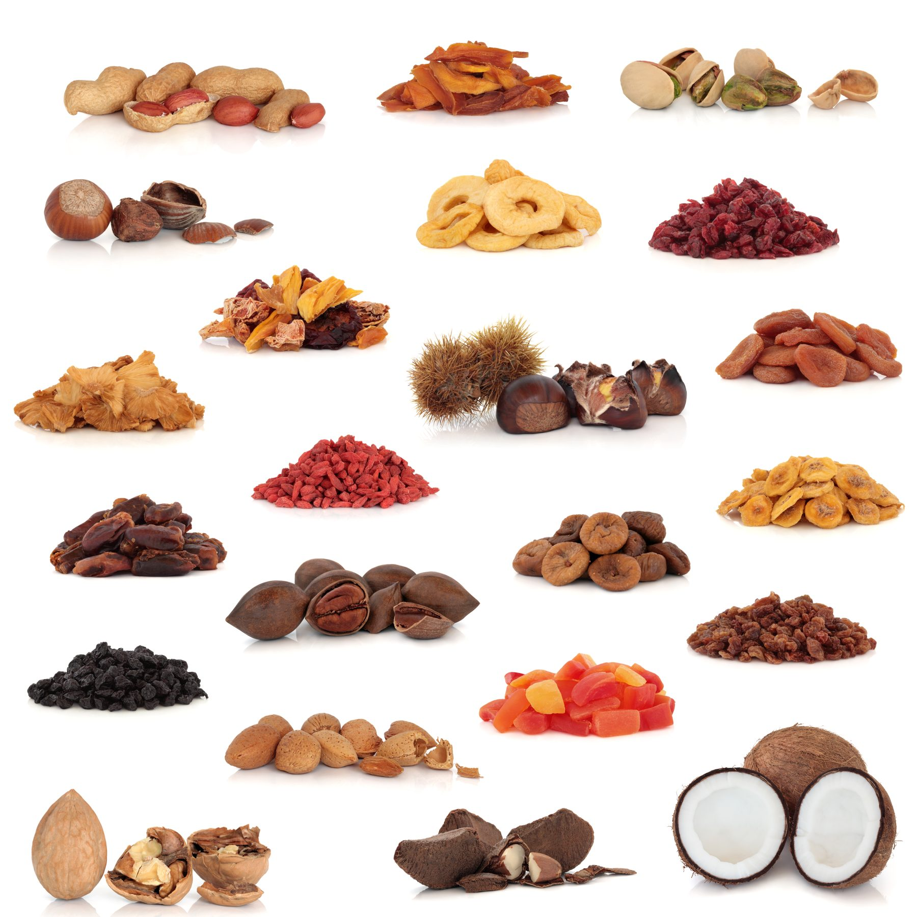
Nuts
Nuts are a good source of protein, fibre, vitamins and minerals. While nuts are high in fat, the fatty acids in nuts (except coconuts) are mostly polyunsaturated.
This type of fat is considered desirable in our diets. Nuts vary in composition, but most nuts contain more fat than anything else.
Nuts are most versatile in cooking. Varieties most commonly used in hot and cold desserts include almonds, chestnuts, coconuts, hazelnuts, macadamias, peanuts, pecans, pistachios and walnuts.
They can be purchased in many forms including: fresh, in its kernel, salted or unsalted, loose or pre-packaged, whole, blanched, roasted, chopped, crushed, slivered, ground/meal, kibbled, paste or oil.
Almonds – available natural (skin on) and blanched (skin off) in many forms: whole, split, silvered, chopped and ground / meal.
Chestnuts – must be cooked. They are available whole, frozen, glace and puree.
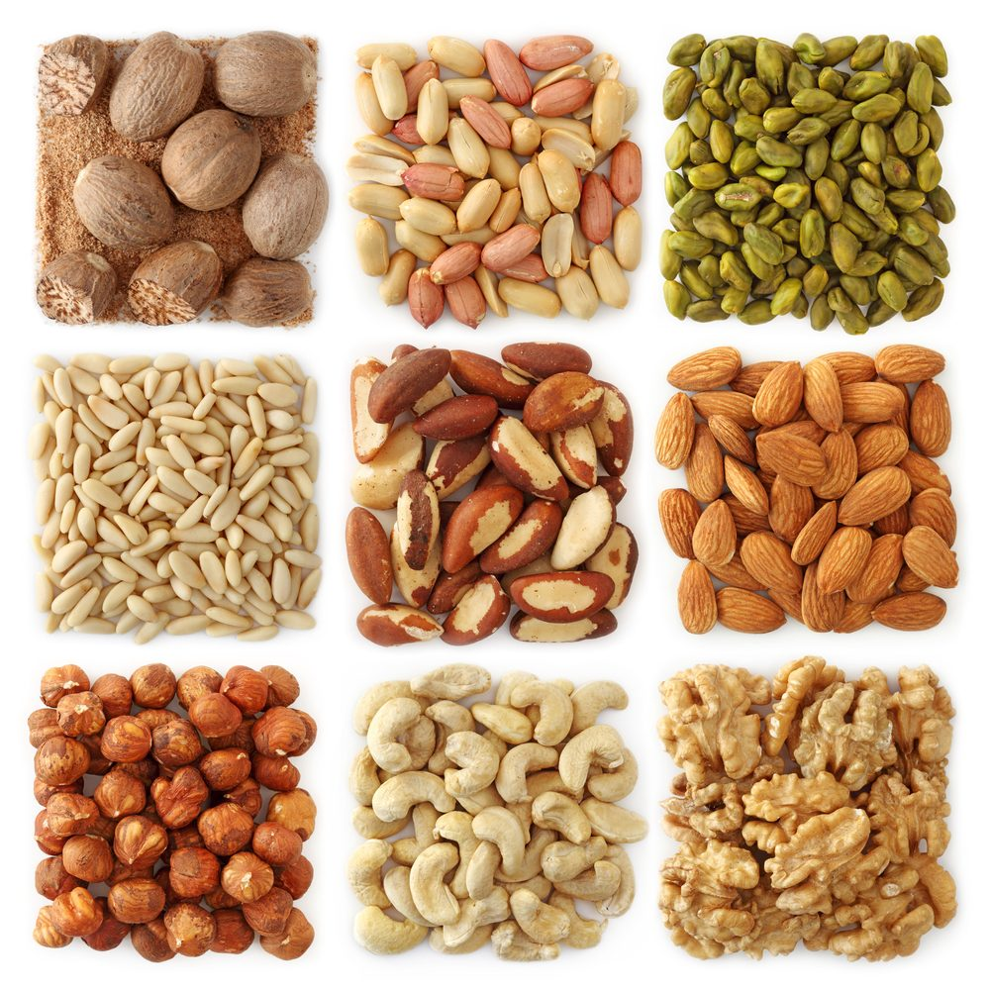
Coconut – is available in many forms. Usually for the pastry kitchen, it is purchased as desiccated, shredded or flaked. Coconut can also be purchased fresh and is used for its milk, cream, or fresh shaved flakes for garnishes.
Hazelnuts – available natural (skin on) and blanched (skin off) in many forms: whole, split, chopped and ground / meal.
Macadamias – are usually purchased whole or chopped with no skin.
Pecans – available whole with the skin on or chopped.
Peanuts – available whole and crushed. They can be sold roasted and also salted.
Pistachios – available in their skin whole and chopped, as well as blanched and then silvered. Blanched pistachios are bright green.
Walnuts – available whole, as halves, chopped and crushed.
Many nuts are also available as a paste (e.g. almond, hazelnut and pistachio). These pastes are use in the pastry kitchen for the production of many ice creams, mousses, cream desserts, petit fours and in cake production.
The pastes tend to be quite expensive, however the flavour is very intense and only small amounts are required to achieve the desired taste.
Storage
Most shelled nuts benefit greatly from being stored in very clean airtight containers. These containers are best made from non-porous plastic.
Due to the high fat content in nuts, they are prone to quick spoilage; hence by storing in the cool room, or for long term storage in the freezer, you will slow down rancidity.
Most nuts have a shelf life up to 3 months if stored in optimum conditions.
Nuts also deteriorate rapidly when they are subject to kitchen warmth, uv light and oxygen.
Be aware of insect and weevil infestation in nuts too. This also results in rapid deterioration of their quality and is more likely to occur in autumn (their breeding season).
Quality
All nuts should be:
- Fresh with a good odour
- Sweet taste
- Crisp texture.
Typical of the nut, e.g. walnuts are softer than almonds).
They should also be a good colour, typical of their variety e.g. Walnuts are a light brown caramel colour.
They should be well formed, and free of dark, bitter membranes, insects and weevils.
Roasted nuts have a crisper texture and more pleasant enhanced flavour. This is because the natural fats have been activated during the roasting process.
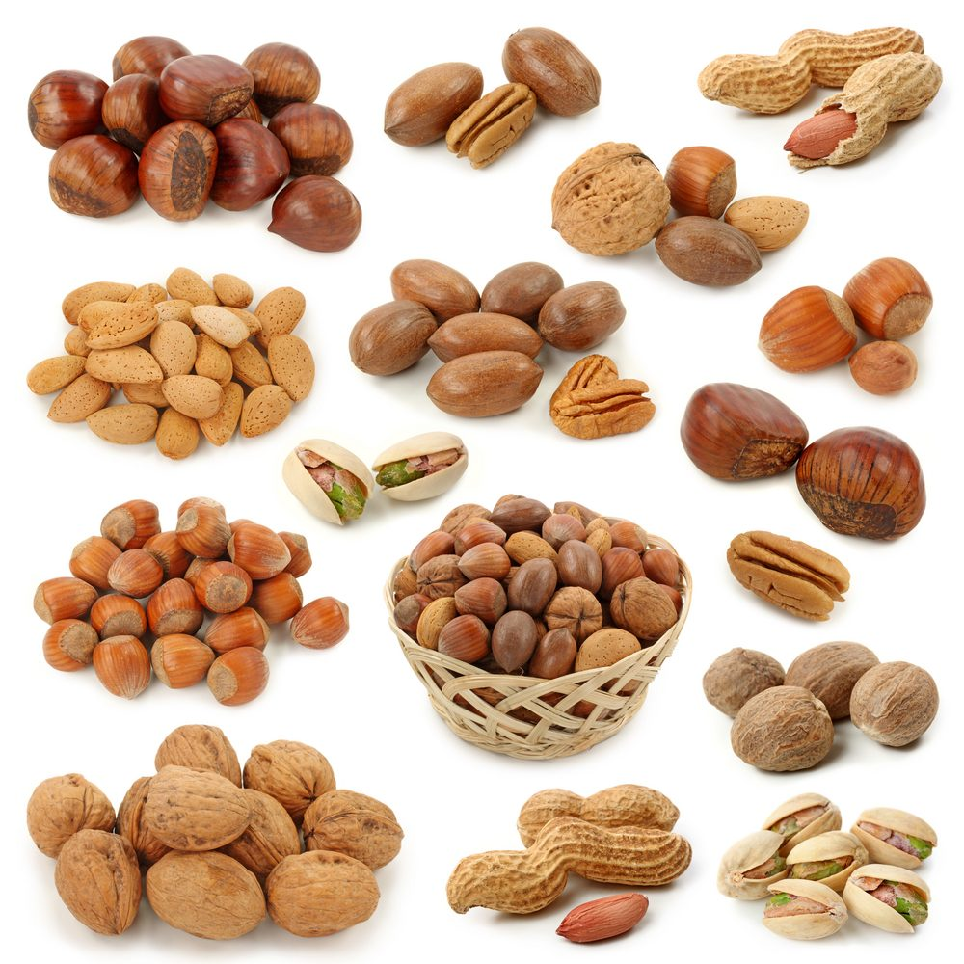
Uses
Nuts are extremely versatile and lend themselves to many dishes, e.g. pistachio ice-cream, almond milk jelly, hazelnut and chocolate flourless cake.
Many nuts may be used for a garnish e.g. flaked toasted almonds, roasted caramelized walnuts, nougatine and praline.
Nuts may also be the prominent flavour and ingredient of a recipe e.g. pecan pie, peanut cookies, almond nougat.
Many people have allergies to nuts, so be sure customers know when nuts are present in a product. One easy and attractive way to alert customers to the presence of nuts is to garnish the top of the item with the type of the nut it contains.
Nuts are toasted to develop flavour by allowing chemical reactions to occur (browning of sugars and proteins) (Mailliard)
Toasting also improves the flavour of slightly stale nuts. Besides improving flavour, toasting also darkens the colour and crisps the texture of nuts.

Flavourings
Vanilla
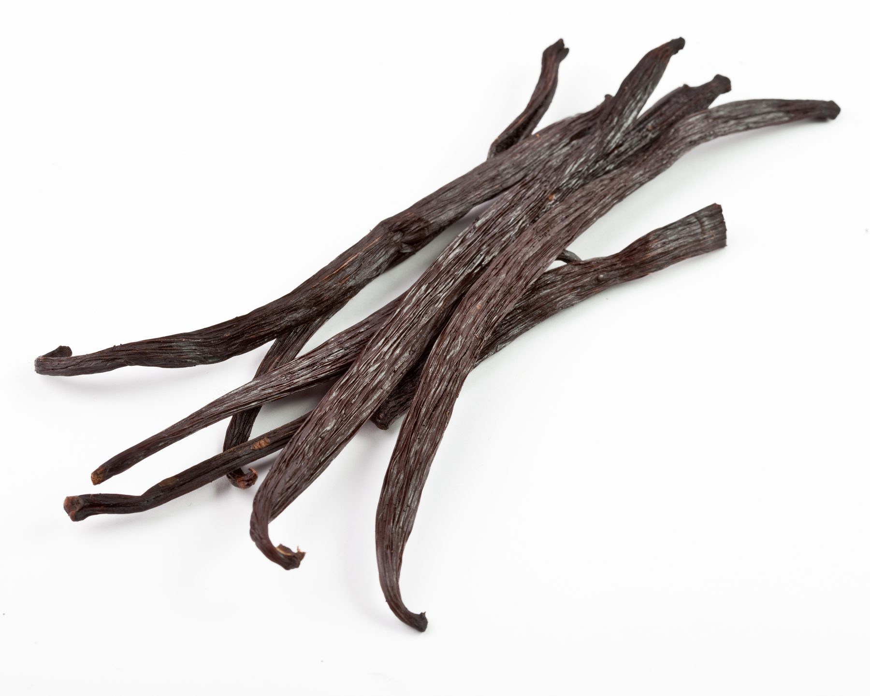
Vanilla, sometimes called the orchid of flavour, is the most widely used flavouring agent in the pastry kitchen.
Its uses are endless because its taste compliments just about every other flavour and improves many of them.
Vanilla also has the distinction of being more expensive than any other flavouring or spice, with the exception of saffron.
The expense is due, in large part, to the length of time –up to a year– required to process vanilla from blossom to high quality cured bean.
Authentic vanilla bean is really the dried stamen from an exotic orchid grown in Mexico and parts of South America. The bean is also known as a pod.
It should be dry, soft, a little ribbed and pointed at one end.
When spilt open, the deliciously fragrant and sweet seeds are exposed and ready to be scrapped out.
They may be used to infuse and perfume crème Anglaise, crème caramel, brulee, etc.
The pod, once used, may be washed, dried and stored in sugar to again, impart its delightful heady perfume.
The longer the vanilla is left in the sugar, the stronger the flavour (minimum 1 week).
Vanilla may also be purchased in other forms, including:
1. Pure vanilla essence – a flavouring agent made by aging a mixture of vanilla beans and alcohol. To be labelled as pure, it must contain a specified ratio of vanilla to alcohol
2. Imitation vanilla essence – This is an inferior product to pure vanilla essence. It is made using vanillin.
3. Vanillin – are fragrant, powdery white crystals that form on the outside of vanilla bean pods during their curing process. It is used to flavour artificial vanilla extract
4. Pure vanilla paste – is an intensely flavoured thick paste made from vanilla beans.
Storage of Vanilla Bean
Vanilla bean is best stored in an airtight cellophane packaging or immersed in sugar.
Either way keeps it airtight, in a clean, non porous container and away from heat and UV light.
For maximum shelf life and also to prevent the pods drying too fast, store in the refrigerator.
Essences are based on alcohol. Some countries alcohol consumption is not allowed.
Flavoured waters are used to impart flavours into desserts and pastries
Aromatic Waters
Orange Blossom water, which is made from the distilled flowers of orange trees, can be purchased as a concentrated essence or diluted water.
It is highly fragrant and a few drops are all that is required to impart the aroma.
It is used extensively in many countries in many ways. In the Middle East it is used in meat dishes, fruit syrups and fruit salads.
A classic Moroccan salad of grated carrot has orange blossom water sprinkled over it.
In France it is often used to flavour biscuits, cakes, almond pastries and milk puddings.
Rose Water is used in many dishes similar to orange blossom water; however rose water is not as strong in flavour.
It can be used to flavour sugar syrups, honey or poured over desserts and pastries typically in the Middle East such as baklava and Turkish delight.
In England it has been used to flavour game meat and to flavour puddings such as mousses, fools and rice puddings.
It is also used in Morocco sprinkled over fresh fruit such as oranges or strawberries or to flavour yoghurt that is served with fruit.
Rose water can be heated as it will not lose its flavour.
The ancient Egyptians, Greeks and Romans managed to extract fragrance from the rose by steeping petals in water, alcohol or oil.
Water distillation is the oldest method used, however, nowadays, steam distillation is the preferred method, producing a more delicate and fragrant product.

Gelling and Thickening Agents
Gelatine
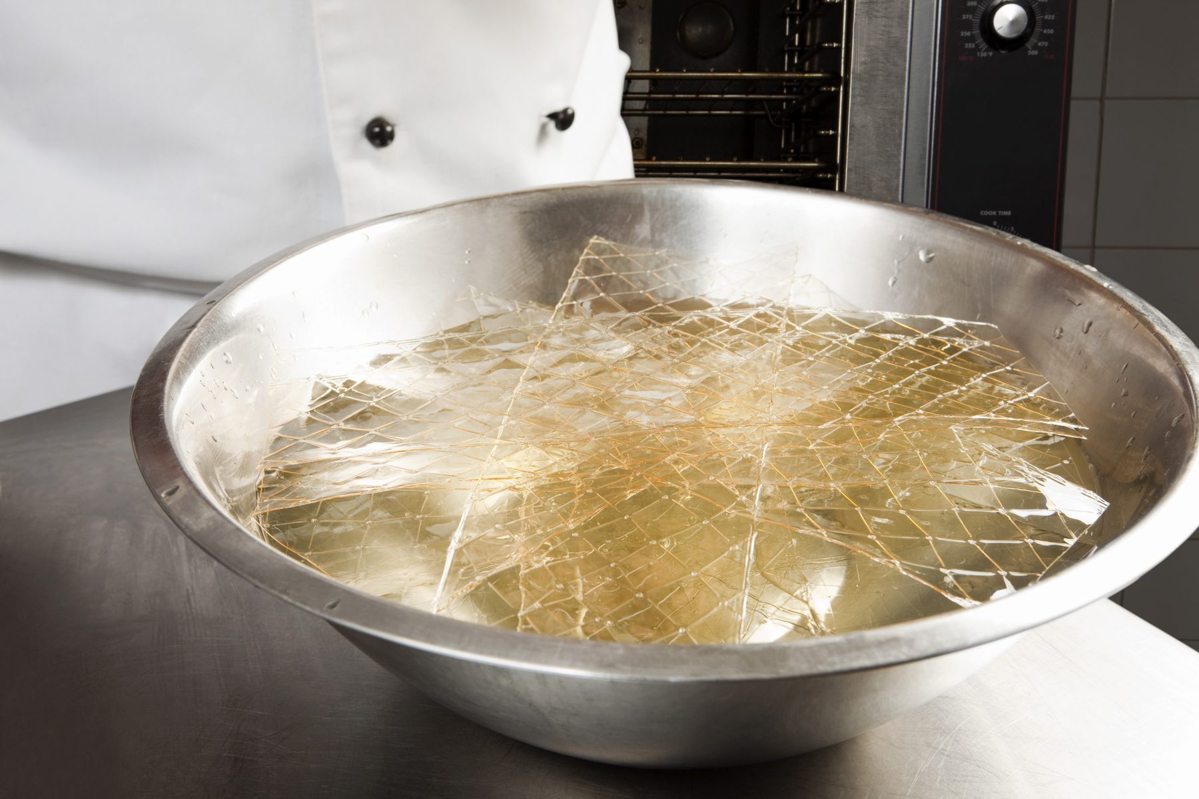
Gelatine is a setting agent made from the tendons and bones of calves, cows and pigs, with most food grade gelatine being extracted from pigskin. Gelatine is a clear product that has no flavour, which makes it suitable for use in desserts.
Gelatine has many uses. It is a necessary ingredient in bavarois, fruit mousses, and cold soufflés. It is a good stabilizer for whipped cream and many cake fillings, and provides the characteristic texture of marshmallows and gummy confections.
Gelatine is available in leaf (sheet) or powered form.
To use gelatine; the required quantity must first be ‘softened’ in cold water, and then added to a hot liquid to dissolve. If gelatine is boiled it may lose its setting qualities.
Gelatine needs to be chilled to set the liquid; it will not set at room temperature.
The various brands of gelatine require differing amounts to set an amount of liquid. Always follow the instructions on the packet; do not rely on the quantities set out in the recipe.
Some fruits such as pineapple and pawpaw contain enzymes that affect the protein in gelatine and it will not set.
Setting Strength of Gelatine
The setting strength of gelatine is referred to as ‘bloom’.
- Silver - 150-160 bloom
- Gold -180-200 bloom.
Bloom is not marked on the packet when you purchase. You will need to contact the manufacturer to get correct setting strength.
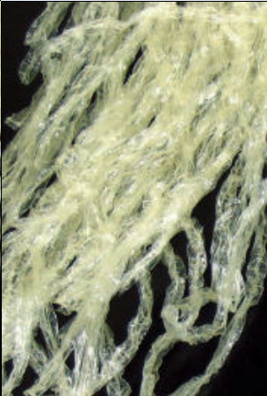
Agar Agar
Agar agar is a natural vegetable based substance extracted from a type of Japanese seaweed and is used in the pastry kitchen to thicken and jell products in the same way as gelatine.
It is available in its natural form of greenish strips, or as a fine white powder. The strips must be soaked for a minimum of 12 hours prior to use. The powder must be heated close to boiling point to dissolve fully and will set strongly when cooled.
It is suitable for vegetarians and in kosher preparations. It has almost triple the strength of gelatine. Agar agar is principally used in the pastry industry for cream desserts, ice creams and sauces.
Products set with agar agar will remain firm at room temperature, unlike those set with gelatine.

Pectin
Pectin is present in all fruits, but fruits vary in the amounts they contain. Fruits high in pectin include: apples, plums, cranberries, raspberries and citrus peel.
These fruits can be made into jams and jellies without any added pectin. Pectin thickens, and in the presence of acid and high amounts of sugar, it gels. Pectin gels are clear, not cloudy and have an attractive sheen and clean flavour.
Pectin is commonly used in glazes, jams and jellies, bakery fillings and fruit confections. It can be purchased as a dry powder, which is typically extracted and purified from citrus peel or apple skins.
Tapioca
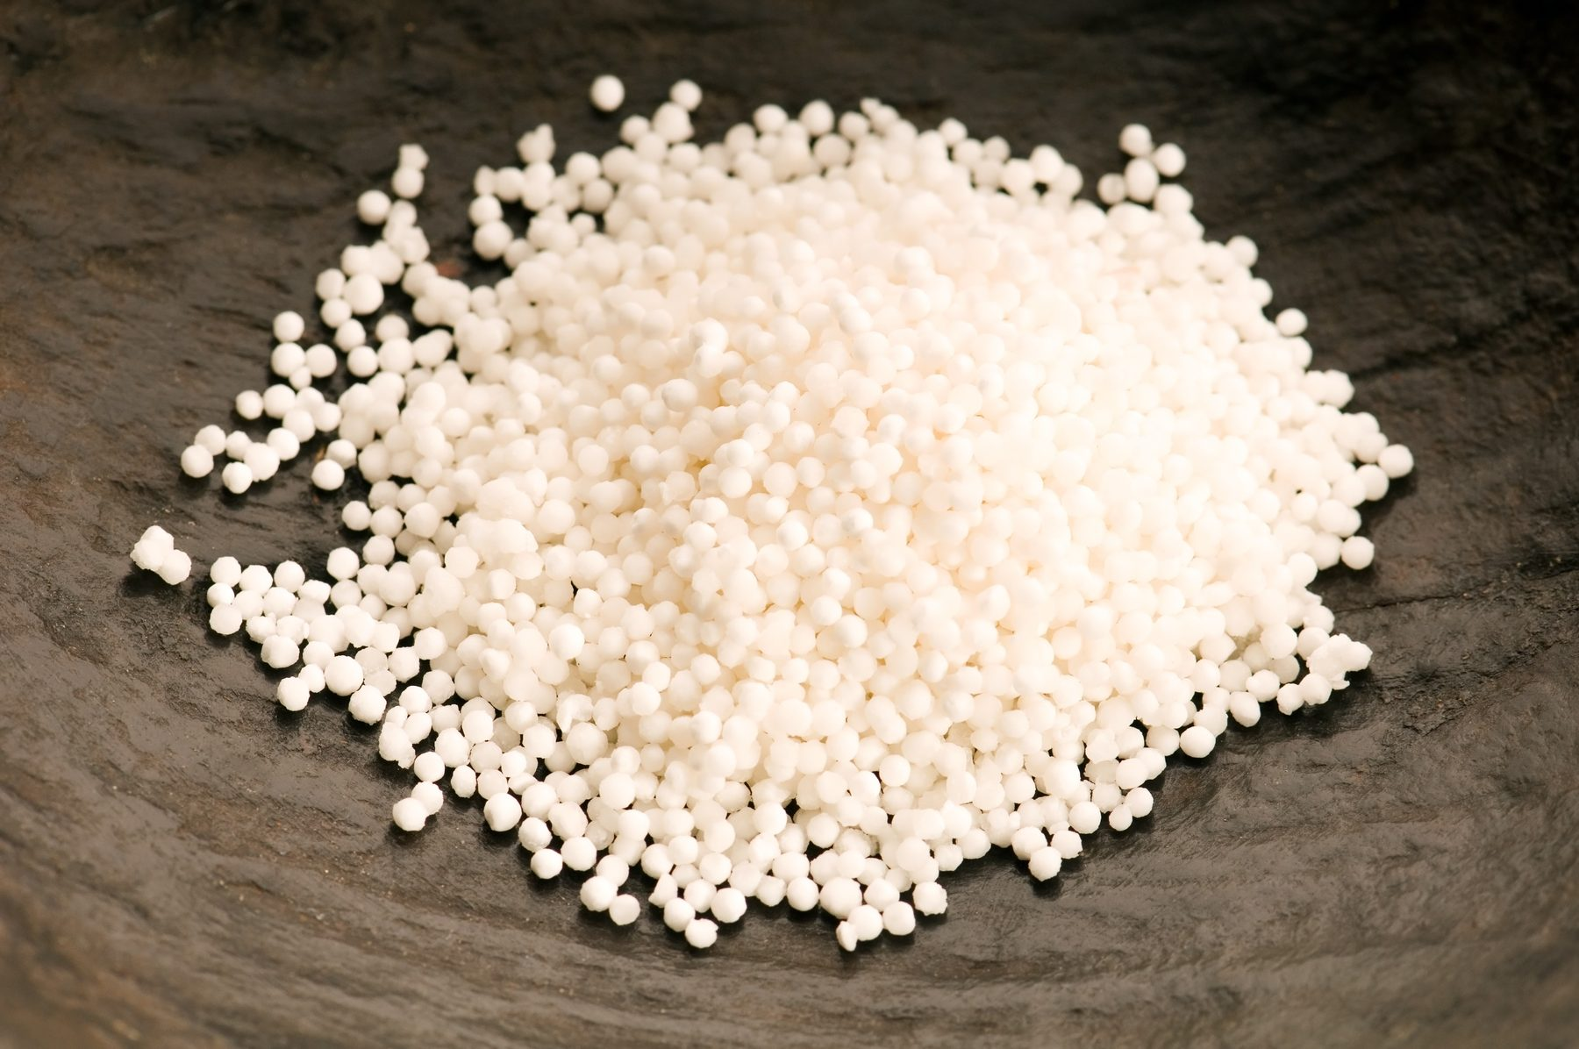
Tapioca is virtually pure starch. It is extracted from the root of the tropical cassava or manioc plant.
The word tapioca comes from a term used by the Brazilian natives meaning to press or squeeze out residue, in reference to the way the starch (tapioca) is extracted. The roots are crushed and stepped in water, and the liquid is then pressed out.
Tapioca is available in several forms, including pure starch or flour, quick cooking granules, flakes and pearls. When the pearls are cooked, the tapioca does not dissolve completely; instead, the small particles become translucent and soft.
Pearl tapioca must be soaked before cooking and is often used for tapioca pudding - a custard like dessert. Tapioca pudding is commonly found on Asian influenced dessert menus.

Thickening Agent Characteristics
Starch | Properties | Ideal uses
Cornstarch | Cloudy when cooled  Not stable with high acid products, excessive heat, freezing , mixing  Gel weeps over time  High gelatinization temperature  Good sheen  Masks many flavours. | Puddings  Cream pies
Arrowroot | Moderate to high clarity  Relatively stable against acid, heat, mixing, freezing  Relatively low gelatinization temperature  Clean flavour. | Fruit pies  Sauces
Tapioca | Moderate to high clarity  High sheen  Relatively stable against acid, heat, mixing, freezing  Relatively low gelatinization temperature  Clean flavour. | Fruit pies  Sauces  Tapioca pudding
Flour | Cloudy, yellow colour  Heavy body  Imparts a flavour. | Pastry cream  Pie fillings
Gelatine | High clarity  High sheen  Forms very thin, bouncy gel. | Gelatine based desserts  Stabilized whipped cream  Confections
Agar agar | Moderate clarity  Forms very firm, bouncy gel  Stable at room temperature. | As a gelatine substitute for vegetarians and Muslims
Pectin | High clarity  Thickens or gels  Clean flavour  Generally requires high acid and high sugar concentrations. | Fruit jams and jellies  Fillings  Glazes  Jelly confections

Fruits
Everything You Need To Know About Fruits
Fruits are classified into the following groups:
Soft fruits | Strawberries, raspberries, blackberries, boysenberries, blueberries, gooseberries, grapes and currants (red, black & white).
Stone fruits | Apricots, peaches, nectarines, plums, mangoes, cherries.
Hard fruits | Apples, pears and quinces
Citrus | Lemons, oranges, grapefruit, mandarins, cumquats, limes, pomelo, tangelo
Tropical | Bananas, pineapple, lychee, rambutan, jackfruit, dragon fruit, guava, tamarillo, pawpaw, custard apple
Miscellaneous | Rhubarb, kiwifruit, persimmon, passionfruit, pomegranate, fig, watermelon, cantelope, honeydew
Quality points:
- Fresh fruits are best purchased ripe so their flavour and texture are at their best
- A good appropriate colour and smell will assist in determining good quality
- Fruits should be a uniform and appropriate shape
- Should be free of blemishes
- All fruits must be free of insects.
The following fruit categories have other quality points such as:
Soft fruits | Mould free  Dirt free
Stone fruits | Mould free  Not bruised
Hard fruits | No bruising
Citrus | Mould free  Skin to be firm, not soft
Tropical | No bruising
Miscellaneous | Good colour  Firm to touch  Melons should be heavier than they look.
Purchasing:
Fruits can be purchased in many forms as listed below with some examples:
- Fresh – by variety, such as fuji apples, corella pears
- Individually, kilo, punnets, tray, box or case
- Pre-prepared – fruit salad, sliced mango, pineapple slices
- Dried – apple, apricot, banana, blueberry, cherry, citrus peel, cranberry, currant, date, fig, ginger, kiwifruit, mango, melon, mixed peel, muscatel, pawpaw, peach, pear, pineapple, plum, prune, raisin, sultana
- Candied – orange, cherries, pineapple, apricot
- Canned – apple, apricot, cherry, grapefruit, lychee, mandarin, mango, passion fruit, peach, pear, pineapple
- Crystallized – citrus peel
- Frozen - strawberries, raspberries, blackberries, boysenberries, blueberries, currants and some Asian fruits
- Bottled – apricot, peach, plum, boysenberry, quince, cumquats
- Freeze Dried – intense flavour no moisture, difficult to store over time.
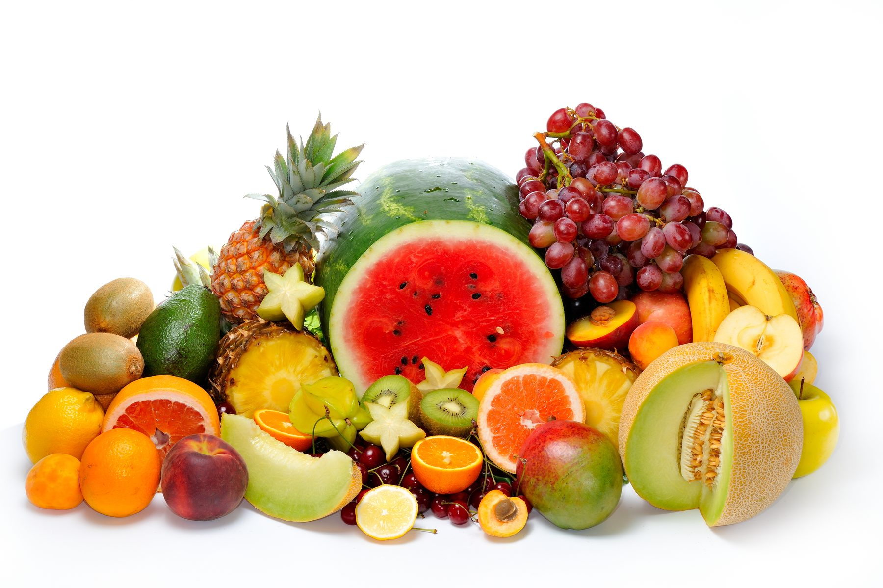
Availability
Seasonal availability will determine price and will also affect your decision to use products in the menu.
Seasonality still exists today but not to the same extent as before improvements in mass transport and distribution, storage and changes in growing conditions:
- Growing in hot houses in Queensland to supply southern markets in cooler months.
- Controlled atmosphere delays repining and extends availability of fresh fruits to the market.
When using fresh you will need to develop knowledge of what is available when and how the price affects your bottom line, profit margins.
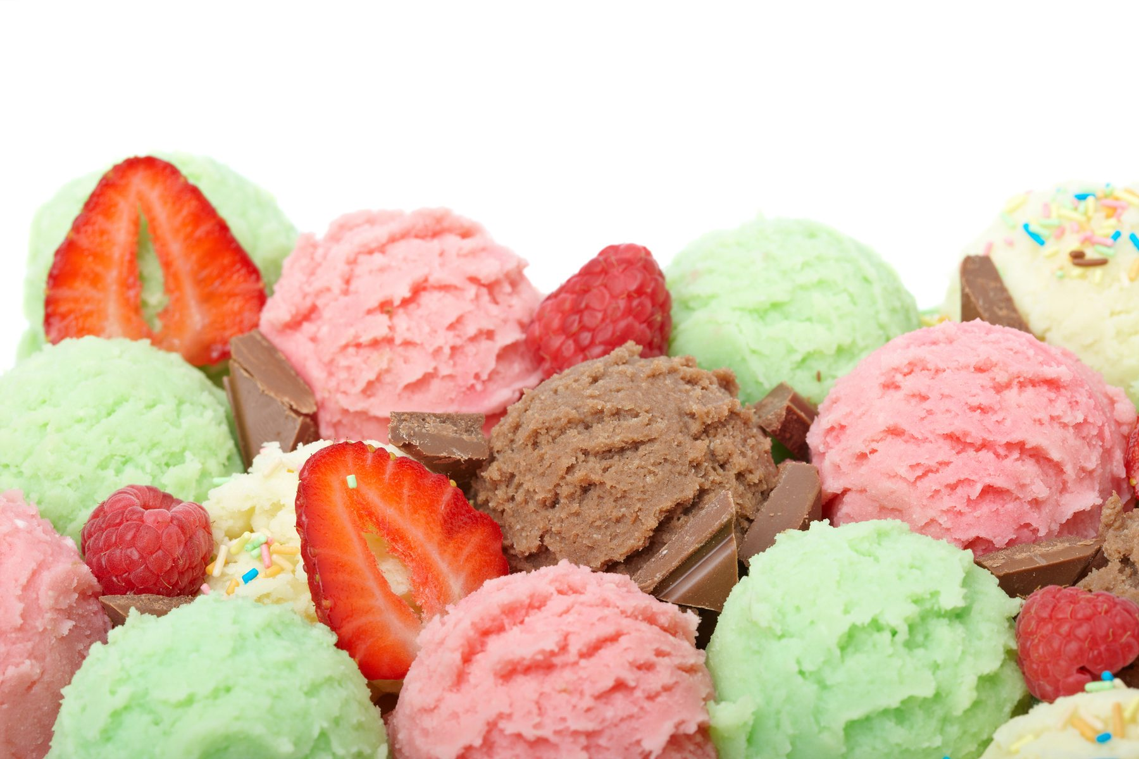
Even when fruits are in season and the prices are at their lowest it is sometimes more economical to use fruits frozen than using fresh:
- Fruit coulis
- Ice cream and sorbet flavouring.
are best made from frozen fruits.
Excess or damaged fresh can be incorporated into these to cut down on wastage.
Storage
Fruits contain a lot of sugar and have a soft cell structure. If the cell walls and skin of fruit are damaged they are susceptible to an attack from airborne yeast and moulds, which results in bruising. To retard yeast and mould attack, it is necessary for us to handle fruits carefully and cool store them.
The shelf life of most fresh fruit is prolonged through storage at 6 – 8º C.
Soft fruits and some stone fruits do not like prolonged periods in the fridge, as they are sensitive to chilling.
However some fruits like banana are susceptible to discolouring when chilled and require storage at a warmer temperature such as the dry store.
Some fruits such as citrus and hard fruits can be stored in the dry store; however the shelf life is shortened.
Fruits that need to ripen naturally can also be stored in the dry store in brown paper bags to increase the ripening process, e.g. stone fruits.
Fruits should be stored away from strong smelling ingredients e.g. basil, parmesan cheese, garlic.
It is best to eat fruits at room temperature as their flavours are more pronounced.
Basic Preparations of Fruit
When preparing fruits specific requirements can be needed for a particular dish.
Basis preparation requirements could be as follows:
- Peeled completely
- Neat clean cuts
- Membrane and pips removed from citrus
- Pineapple needs to have the eyes and core removed, apples must have seeds removed, bananas need the fibrous membrane removed.
When preparing fruits for a plate of fresh fruit or salad, a variety of colour, flavour and texture needs to be considered. Fruits must be fresh, ripe and full of flavour.
- Wash fruit when you are serving the whole piece e.g. strawberries would be washed, yet a pineapple wouldn’t be as its skin is removed prior to consumption.
Preparation of fruits should be appropriate to the dish
- Hulled strawberries
- Cherries pitted
- Skin removed
- Grapes peeled and deseeded.

Poached fruit:
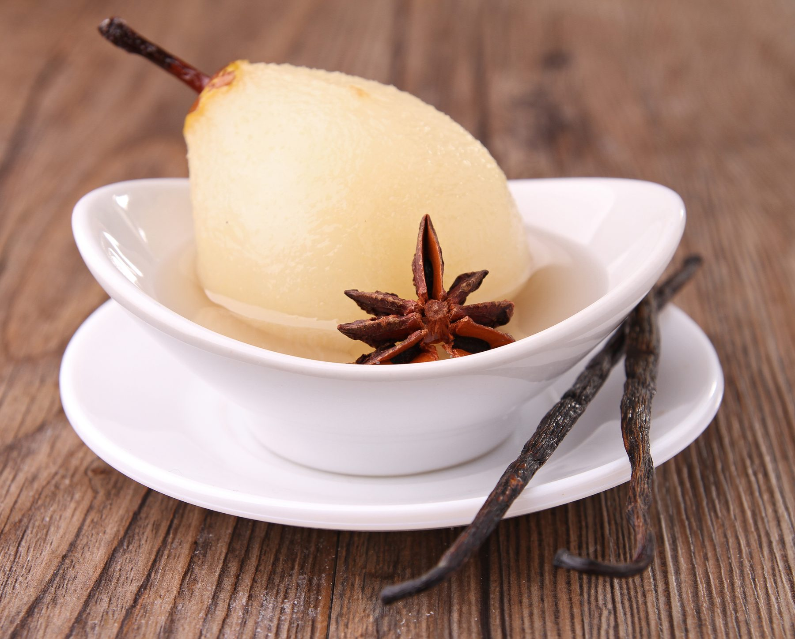
Fruit used for poaching should be ripe and free of any blemishes. The liquid used for poaching is mostly sugar syrup (1: 2 – 1: water: 2 : sugar).
Extra flavour may be incorporated using wine, spices, herbs, liqueurs.
The procedure of poaching depends on the ripeness and the consistency of the fruit to be poached:
- The sugar syrup is boiled and poured onto the fruit and cooled immediately:
- Suitable for soft fruits
- The fruit is placed into the cold sugar syrup, brought to the boil once and cooled:
- This method only applies to very ripe fruits such as stone fruits that don’t require too much cooking
- The fruit is placed into the nearly boiling sugar syrup and poached until soft, then left in the syrup to cool:
- This is appropriate for hard fruits like quinces and pears.
Candied fruit
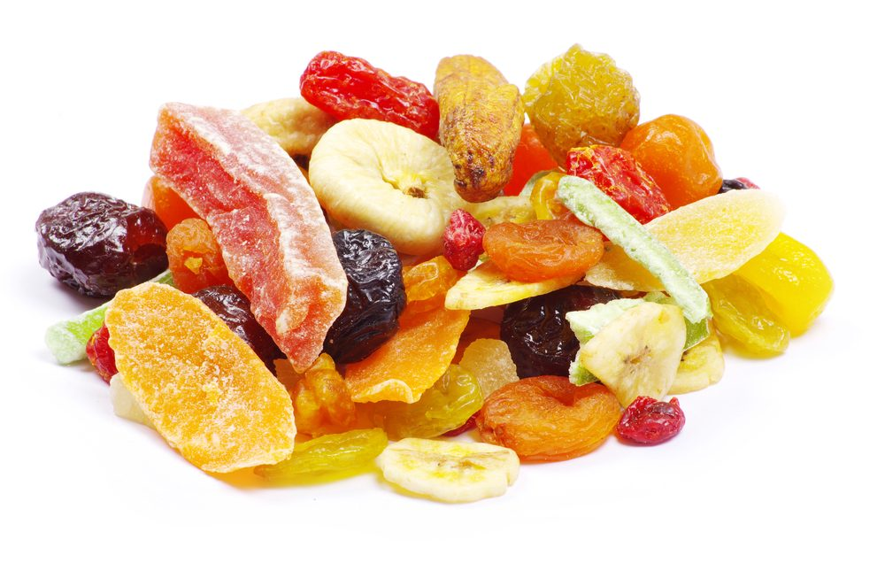
Fruit is poached in sugar syrup until soft. It is then placed into a 20ºBaumé hot sugar solution.
During this period, water in the fruit exchanges with the sugar solution. After 24 hours drain off the sugar solution and boil 2-3º higher. This is repeated until the solution is 36°Baumé. 10% glucose of the sugar weight is recommended, to avoid crystallisation of the sugar.
Citrus fruit may be blanched to remove bitterness prior to candying.
To candy nuts: sugar syrup is tossed with the peeled and skinned nuts and then baked at 150°C until the syrup is completely evaporated. Nuts then brown and the sugar crystallises, to early caramel stage.
Caramelised or baked fruit
Fruit is sprinkled with sugar, which is either placed in an oven, salamander or torched with a blowtorch:
- Heat caramelises the sugar, which then changes the flavour and the colour.
It also leaves a very high gloss on the product. Fruit may also be dipped into liquid caramel; this method does not give much flavour improvement.
Marinated or Macerated fruit
Fruit is soaked with alcohol and sugar syrup over a period of time, usually from 6 months to 1.5 years. The container with the fruit needs to be airtight, to prevent spoilage occurring from the presence of oxygen.

Crispy Dried fruit
Fruit is cut into very thin slices, marinated with acid (usually vinegar or lemon juice) and sugar and dried (2 parts sugar : 1 part water : 5% acid).
The fruit is placed into a hotbox or into an oven (100ºC), it will then dry out and become crispy. Soft fruit may be formed into certain shapes and then dried (flowers). Fruits with high acid content are very suitable for drying out into fruit chips, e.g. pineapple, apple, pears.
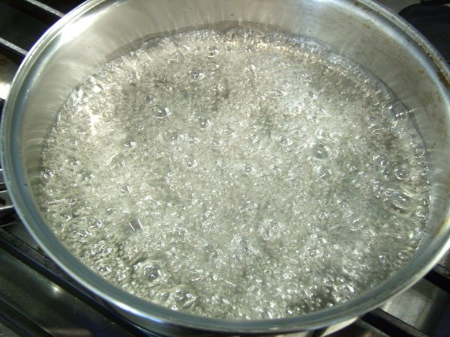
Sugar Syrups
Sugar syrups are used for many preparations in the kitchen.
Sugar syrup can be used as a sauce, usually with other flavours such as rose water or citrus zest. It is most commonly used, with flavouring such as wine, citrus zest and spices to poach fruit. It is used to make caramelized or candied or dried fruits, which can be used as a garnish.
Sugar syrups are made from water and sugar, in different ratios depending on its use.
The ratios of sugar syrup are:
- Equal parts of sugar and water (normal stock syrup),
- 1 part sugar to 2 parts water (light), or
- 2 parts sugar to 1 part water (heavy).
They can also vary from this depending upon their use.
For instance, candied citrus peel may use syrup that has three parts sugar to water and poached strawberries may be 1 part sugar, 2 parts water and 2 parts champagne.
The syrup will also vary upon the ripeness of the fruit being poached.
To make the syrup:
- Place the water in the pot and add sugar
- Bring to the boil, stirring to dissolve the sugar
- Store sugar syrups in a clean container with a lid
- Sugar syrup can keep for an extended period if left unadulterated.
To flavour them you can add ingredients like cut Citrus or Cinnamon stick, Star anise buds, alcohol such as Grand Marnier, Rum, Kirsch, Dark Rum.
Care must be taken, if you add things to the base syrup, that flavour will go into everything.

Pastries in Desserts
‘Pastries’ is a term used to describe products that fall into the classification of Pastry products.
Many will stand alone as dessert but when plated into individual serves can be enhanced with a sauce or cream.
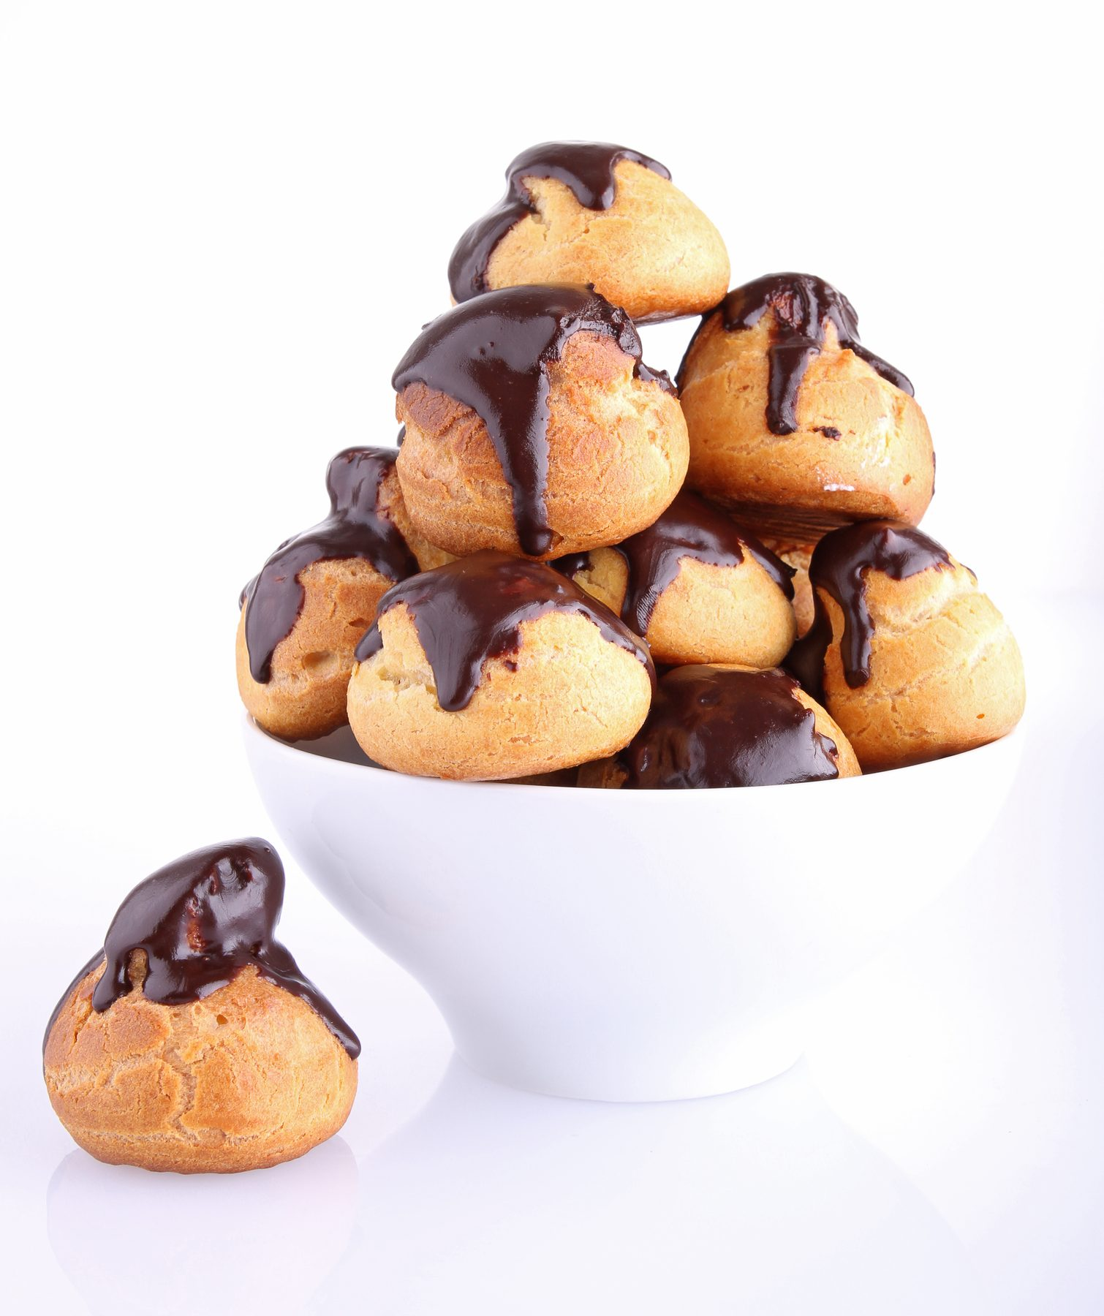
Pastry Types
- Puff Pastry
- Choux Pastry
- Short Pastry: mainly shortbread types but a low sugar and lower fat content can be used
- Filo pastry and strudel dough fall into the short pastry classification but when used with imagination can replace puff pastry without the high level of fat and the specific skill and equipment needed to produce
- Soft aerated pastries or dough: dumpling; suet puddings.
Batters and Coatings
Batters are used to coat products prior to deep-frying or baking.
Batters are also bases of crepes, pancakes
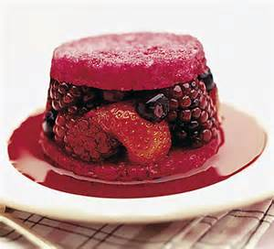
Sweet and Savoury Breads are also used to produce desserts
- Bread and butter puddings
- Queen of puddings
- Summer puddings
- Rum Baba and Savarins
- Dumplings.

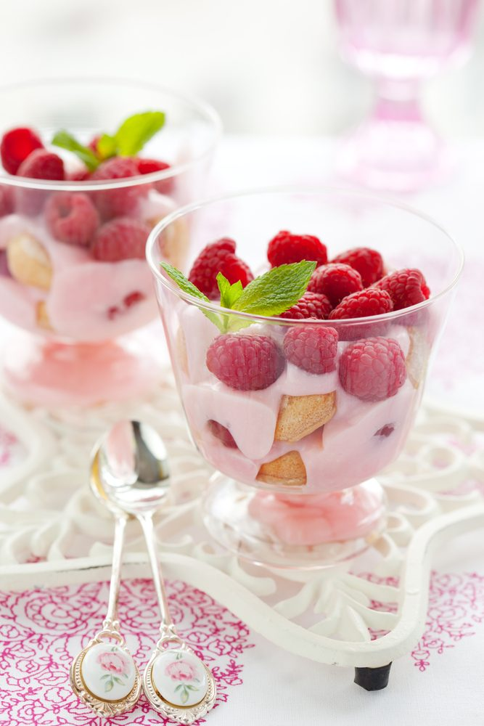
Cake and Genoise in Desserts
Both can be used in the production of quality desserts.
Classic steam pudding is just cake that has been steamed rather than baking. Steaming does not leave a browned outer skin on the finished product.
They will line containers to protect delicate moulded creams: Charlottes, zuccotto
They can be saturated with flavoured syrups to bulk and extend.
This process is also used to cut the richness of some desserts: trifles Tira Mi Su (this is an Italian trifle)

1.2 Prepare a variety of hot desserts according to standard recipes and enterprise standards

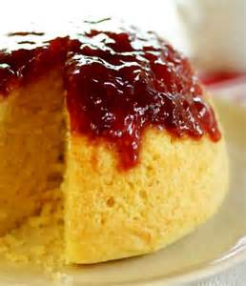
Hot Desserts
Hot desserts are categorised as follows.
Try to list your own examples for each category.
Puddings
- Milk puddings (rice pudding. Sago pudding, semolina pudding, baked egg custards, bread and butter pudding)
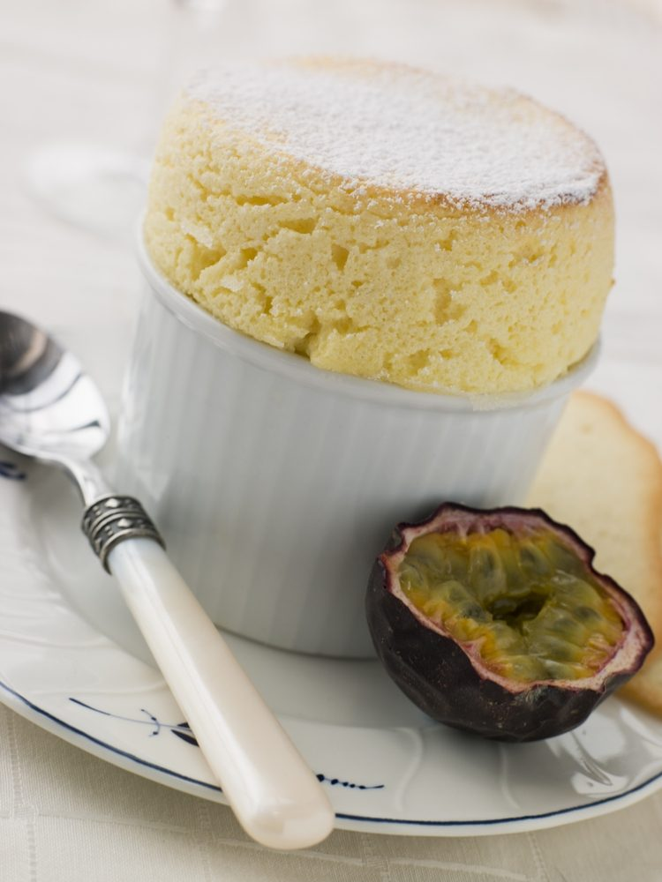
- Steamed sponge puddings (chocolate, lemon, sticky date, etc.) and
- Sweet puddings (Christmas pudding).
Soufflés –
- Meringue based or
- Panada based.
Flavoured, baked in straight sided forms for shape
Fritters or Beignets – which are often fruits battered and fried or a choux paste base flavoured and then fried. Examples include
- Banana and pineapple fritter and
- Ricotta beignets.
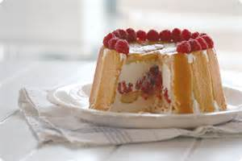
Fruits – baked whole or often in halves (apples, pears, peaches), compotes (berries or stone fruits), fruit crumbles, pies and flambéed fruits.
Charlottes – these can be served hot or cold
Pancakes and crepes - a French crepe is thin and flexible and they call it a pancake. American pancakes are thicker and chemically aerated, savoury or sweet, sold by the stack.
Soufflé Omelettes – starch free aerated egg sugar mixture then cooked in a pan ‘free style’
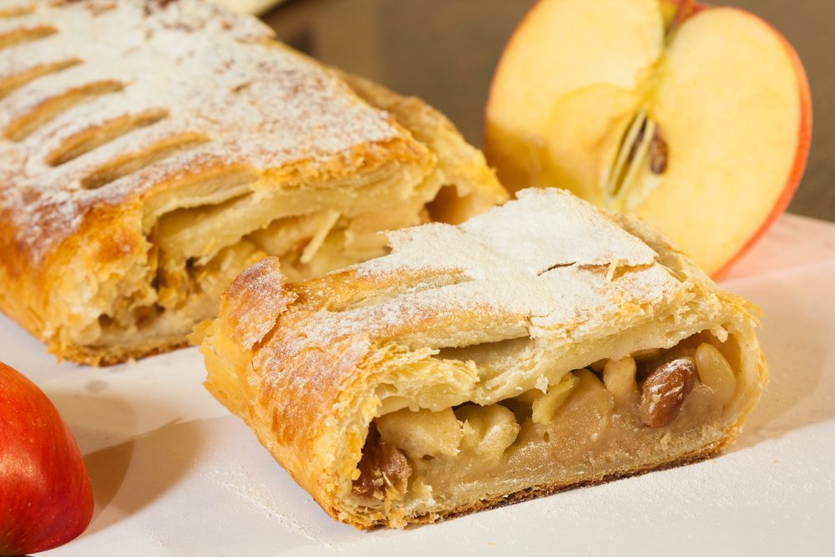
Dumplings – are traditionally more of a European dessert, however a common example that many people may know would be golden syrup dumplings.
Strudels – can be served as a dessert or just for afternoon tea.
It consists of a thin, crisp, pastry that is prepared as a log filled most commonly with apples, however can have any flavour.

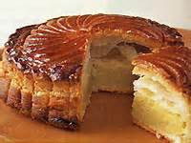
Pithiviers –are a classic French almond cake, made from puff pastry in the shape of ravioli that can be served either hot or at room temperature.
As a dessert they are much better served straight from the oven.
A pithivier is easily recognized by its scoring over the top surface of the puff pastry.

Soufflés
Soufflés are very popular desserts with customers as they look spectacular and are something most people do not make at home.
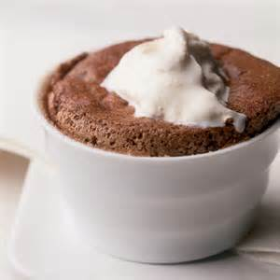
A well-made soufflé should have a “WOW” response from the customers.
Here is a dessert for which the customer will happily wait 20 minutes and pay up to $18.00, when the ingredients often cost no more than $1.20 – a great profit margin!
The French word ‘Soufflé’ literally means ‘to puff’ or ‘to expand’.
Soufflés have a somewhat undeserved reputation as being not only delicate and airy, but also frustrating as they may fail to rise at all, or having done so, may collapse at the wrong time.
Therefore ‘timing is everything’ applies to making a successful soufflé.
Soufflés fall into two categories: sweet and savoury.
Cheese soufflé is probably the best known of the savoury variety.
For the sweet dessert soufflés, Soufflé Grand Marnier and the Harlequin Soufflé would be amongst the most popular.
The Harlequin Soufflé uses two types of batter baked together, offering proof that the soufflé technique has been mastered by the chef.
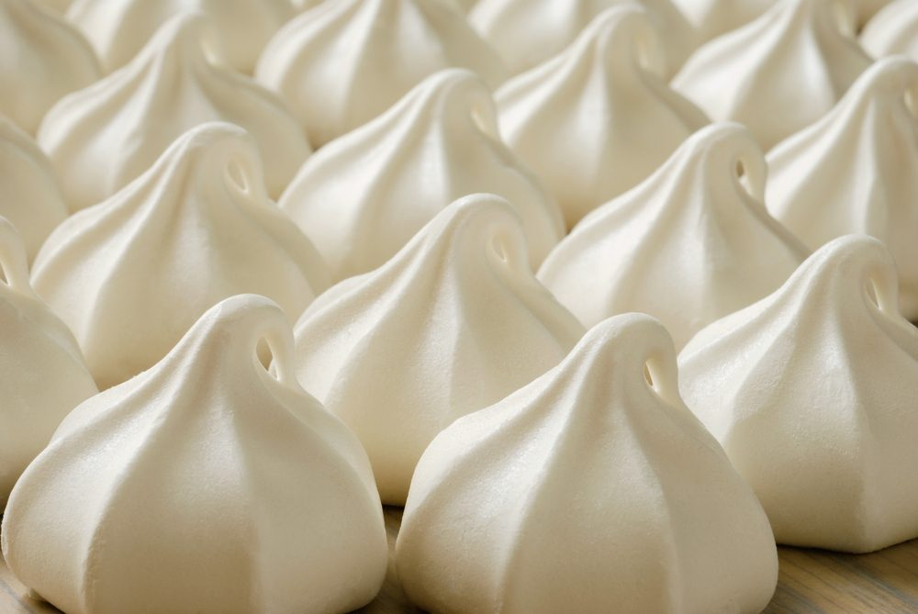
Soufflés can be made in two different ways:
1. Meringue and starch thickened base:
- Crème Patisserie or a panada is used as a base to which flavours are added. A meringue is then folded through
2. Meringue and flavouring:
- This soufflé is made by folding meringue through a flavoured base.
This could include a liqueur, or a fruit puree, or chocolate or marmalade, etc.
Any of these bases could include the addition of alcohol. (i.e. Frangelico and hazelnut paste soufflé)
A liqueur soufflé always rises higher than a fruit soufflé because the evaporating alcohol fumes contribute to the rising process.
Essentially, the air trapped in the whipped egg whites becomes lighter and expands as heated. Soon after the soufflé is removed from the oven, the trapped air begins to escape, and the soufflé deflates like a punctured balloon. This is a good test of a perfectly prepared soufflé.
If a soufflé just sits there high and mighty and never deflates, it is either over baked and dried out from below, or is much too heavy and probably tastes more like a pudding than a soufflé.
For fruit based soufflés, enough moisture must be removed from the fruit pulp to concentrate the flavour and to ensure the mixture is not too thin.
However if the pulp is too dense, the egg whites will not support it.
Sometimes fruit soufflés can be baked inside a fruit shell.
For example: Grand Marnier and orange soufflé in half an orange shell.
To aid the soufflé batter in rising straight up:
- It should always be baked in a traditional round soufflé ramekin with straight sides
- This is then brushed with softened butter in an upward motion (helping the soufflé to rise straight up)
- The ramekin is then placed in the fridge to set the butter
- A second coat of butter can be applied if desired, and then caster sugar is used to evenly coat the butter
- The excess is removed.
Clarified butter and melted butter should not be used on the ramekins, as the film left is too thin and doesn’t aid the soufflé in rising with high straight sides.
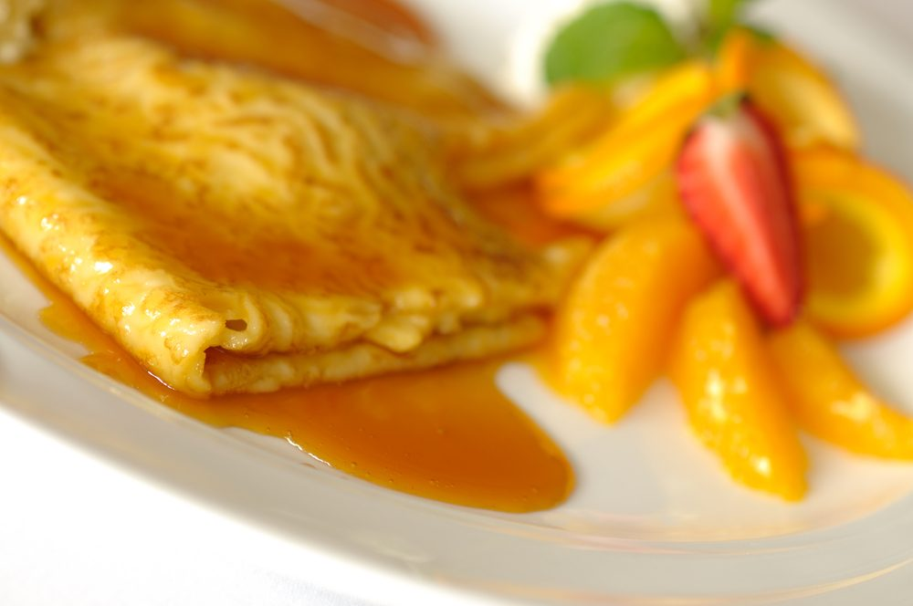
Crepe soufflés are made by baking soufflé batter inside a crepe. This is generally done by spreading the batter on a cooked crepe, folding it in half and baking it ‘a la minute, as any other soufflé.
Other desserts influenced by soufflés are the soufflé omelettes
Characteristics of a well made soufflé are:
- It must be well risen with good height
- It must have risen evenly with straight sides and a flat top
- The meringue and other ingredients must be well blended together
- It should have good well defined flavour
- The top should have a light golden brown colour.

1.3 Prepare a range of cold desserts according to standard recipes and enterprise standards

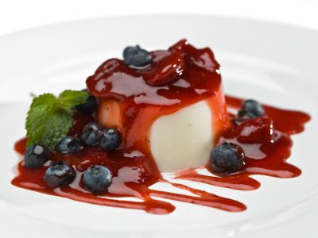
Cream Desserts
There are many desserts that fit this category, including mousses, Pannacotta, bavarois, cold soufflés, tiramisu, trifles and charlotte Russe.
Cream desserts have ingredients in common and subtle differences.
For example:
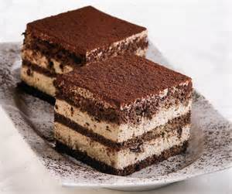
- Mousses and bavarois both have cream, egg yolks and sugar, yet are not made the same way. Different techniques are required to produce each dessert
- Pannacotta has cream and gelatine like a bavarois, yet are made differently
- Tiramisu is sometimes called an Italian trifle yet is different to the English trifle.
All these desserts do use cream, hence their title.
The following table sets out the differences in ingredients for mousses, Pannacotta and bavarois.
Bavarois | Mousse | Pannacotta
Anglaise | Sabayon | Milk & cream
Gelatine | Flavouring | Sugar
Flavouring | Meringue | Gelatine
Lightly whipped cream | Lightly whipped cream | Flavouring

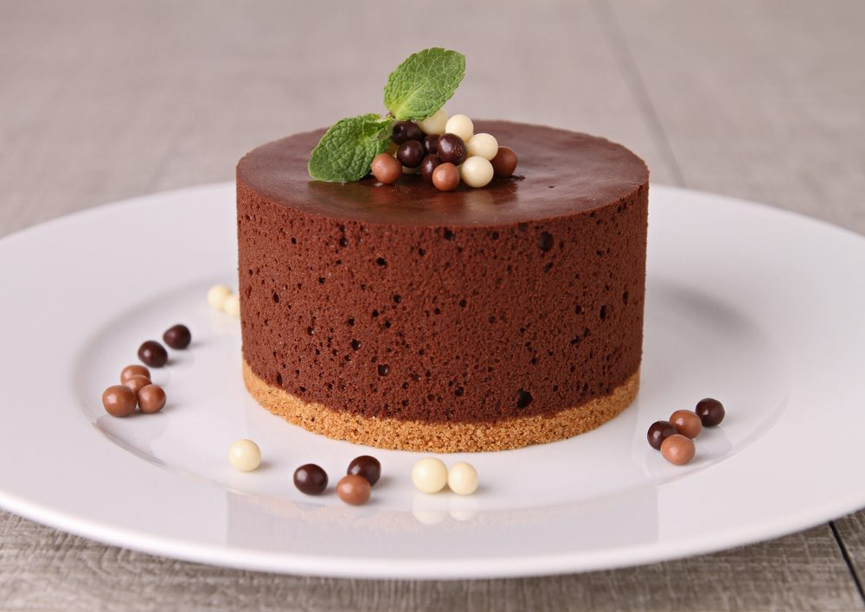
These desserts are usually presented in individual portions.
Mousses can be piped into glass serving dishes or into biscuit shaped into baskets such as wafers or brandy snaps.
They are also used as the filling for a vacherin, which is a mousse layered with crisp meringue.
A Charlotte Russe is a dish lined with sponge finger biscuits and filled with a bavarois mixture, which is left to set then turned out and cut into portions to serve.
Trifles and tiramisu can be set in a large tray and cut into portions, or made as individual portions.
Trifle or tiramisu are often seen on a dessert buffet table, as are pannacotta and mousses, as they can be presented in small portion sizes.
These desserts are all soft in texture and can be garnished with nuts, biscuits, meringue, dried or crystallized fruit, praline or sugar bark to give a crunchy/crisp texture balance to the dish.

1.4 Prepare a range of frozen desserts according to standard recipes and enterprise standards

Frozen Desserts
Types of Frozen Desserts
There is a vast range of frozen desserts found on menus today.
They range from classics like:
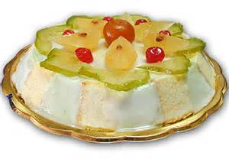
- Bombes
- Parfaits
- Cassata
- Semi-freddo and
- Cherries jubilee
- Ice cream cakes
- Meringue glace
- Soufflé glace
- Frozen mousses.
And special presentations for many delicious and unusual ice creams.
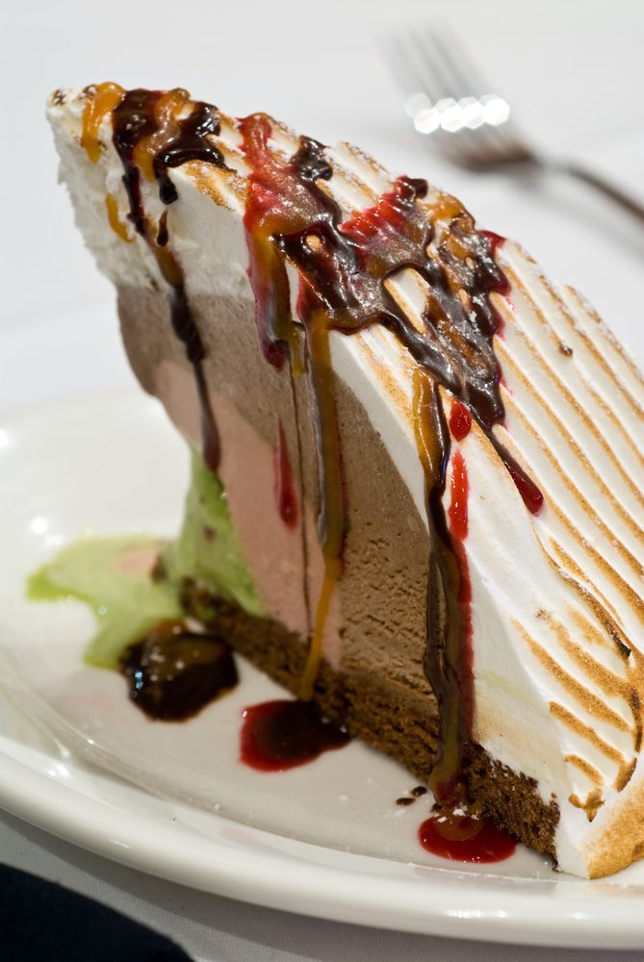
Bombes
A bombe is a type of frozen dessert which typically uses a chilled half sphere mould, lined with ice cream, sorbet or sherbet and then filled with a rich cream mixture.
Most recipes call for multiple layers of ice cream in different flavours and contrasting colours.
When producing bombes, it is essential to freeze each individual layer until firm before attempting to add the next.
The bombe mixture that fills the lined mould is made from egg yolks, sugar and cream in the style of a parfait. It is then flavoured according to the individual recipe, or which there are many classic variations.
When fruit other than candied fruit is added to the bombe mixture, it must first be macerated in liqueur or sugar syrup to prevent it from freezing too hard.

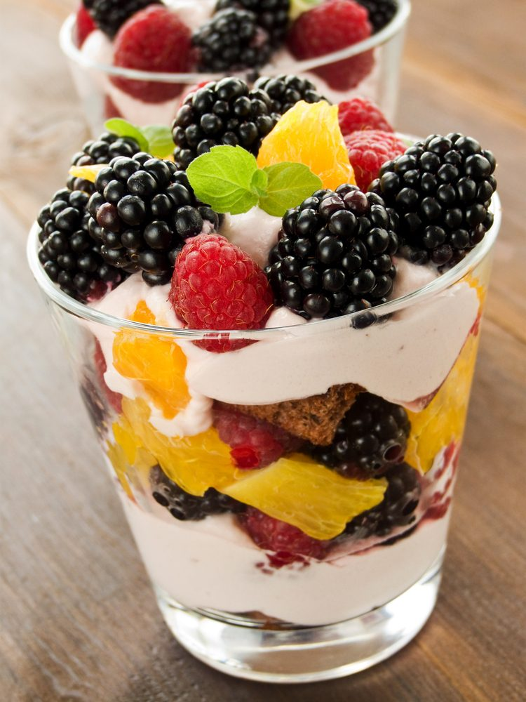
Parfaits
Parfait is used to describe two different desserts – one European and the other American.
The American parfait is a dessert of alternating layers of ice cream, fruit and liqueur, served in a tall glass and topped with whipped cream.
The European parfait is a delicate frozen dessert, usually lighter and less sweet than ice cream, made from a mixture of egg yolks and sugar syrup whipped to ribbon stage, with the addition of whipped cream and flavouring folded through.
It is very important that as much air as possible is maintained throughout its production so as to keep the light texture that is essential for this dessert.
The mixture is poured into moulds and frozen without churning. The parfait is de moulded and allowed to warm for a few minutes before serving.
This is to soften the parfait slightly to produce a far superior eating quality.
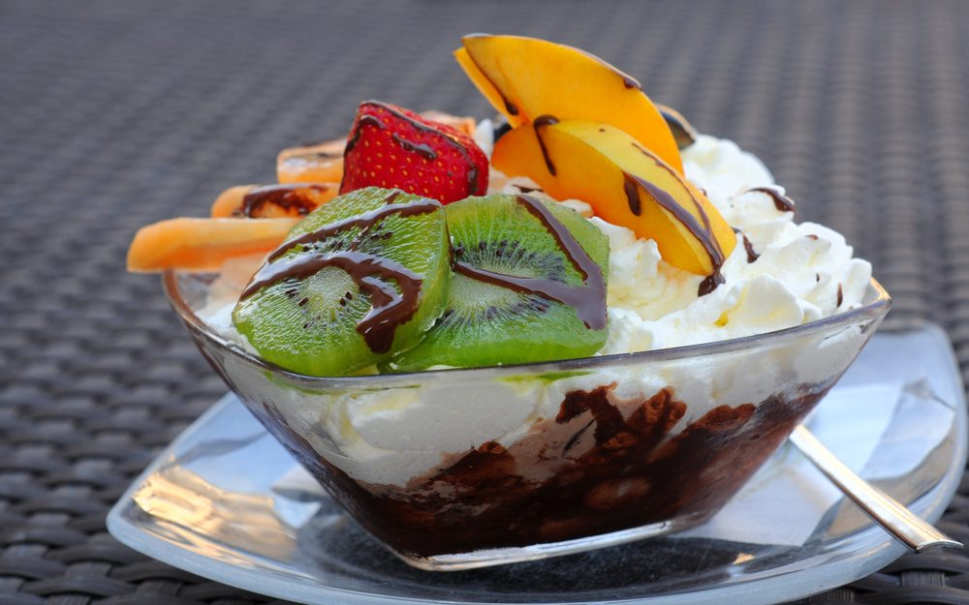
Coupes
These popular and practical individual ice cream servings are made to look attractive by specialty serving dishes.
Coupes are a combination of ice cream and/or sorbets, decorated with sauces, fruits, nuts and can also include whipped cream.
These days we refer to them as ice cream sundaes.
Coupes must always be assembled and decorated to order.
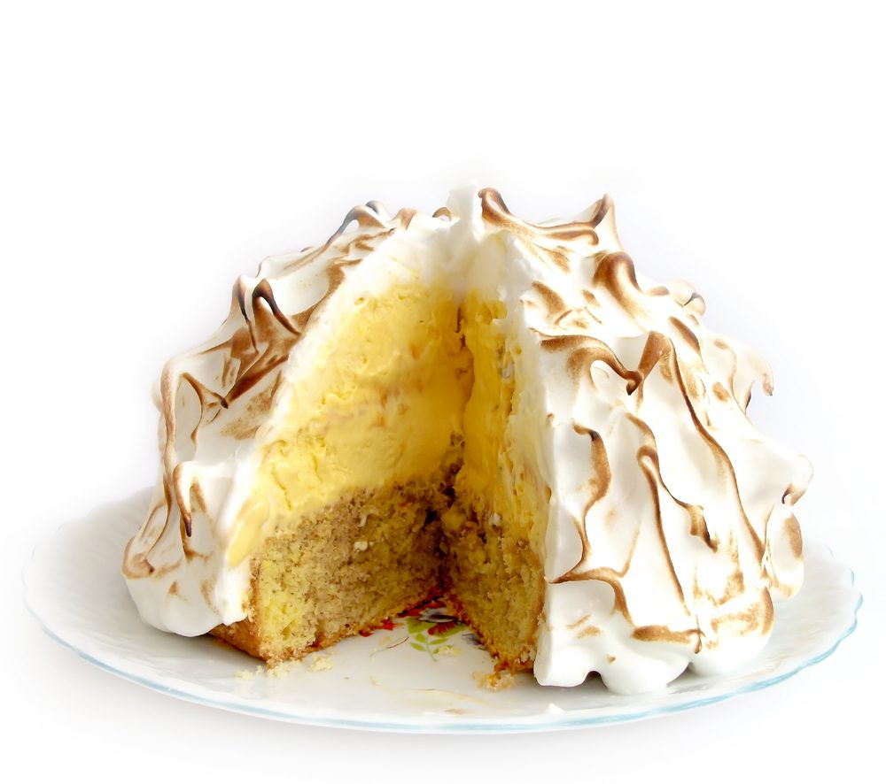
Bombe Alaska
A Bombe Alaska is also known as a Baked Alaska.
It is a classic dessert that combines cold frozen ice cream, wrapped in a thin sheet of soft sponge cake, topped with caramelised sweet meringue.
This dessert was then placed into an extremely hot oven to caramelise the meringue, without melting the ice cream.
Today, the meringue can be browned using a salamander or blow torch but the result is not the same.
The dessert can also be flamed at the table by the waiter as it is wheeled in to the restaurant on the dessert trolley.
Flaming is when a small amount of alcohol is poured over the top of the dessert and is the lit and the alcohol is then burnt off and flavour of the alcohol is residual.
Remember: Care must be taken with this practice as it can be dangerous when alcohol is lit. It EXPLODES!!!!!

Semi-freddo
Semi-freddo is the Italian word denoting a cold dessert, literally half frozen.
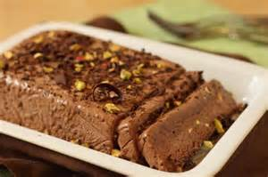
The basic semi-freddo mixture is made from whipped eggs or egg yolks, sugar and various flavourings usually including a spirit or liqueur.
Whipped cream and/or meringue are folded into this mixture and the base is still frozen (no churning).
Semi-freddo is also made by layering the base with cake, custard, macerated fruits, crushed cookies, nuts and chocolate.
They can be made in moulds for multiple servings or as individual servings.

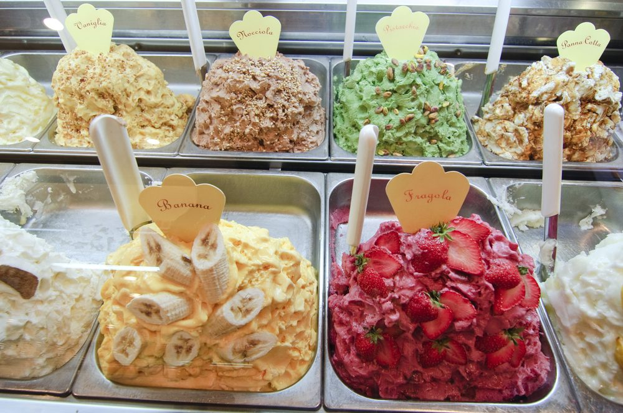
Ice Cream, Sorbets and Sherbets
Ice creams and other frozen desserts in different shapes and combinations have always been favourites of guests and chefs alike.
Ice cream desserts are very practical for the chef because they can be made some days in advance.
Today, with small electric ice cream freezers available at a reasonable cost, home cooks can make ice cream as effortlessly as professionals.
Churning ice cream by hand has become almost obsolete.

Crème Anglaise
The term 'ice cream' usually refers to the custard sauce based variety (Anglaise), which is made from cream and or whole milk, sugar and egg yolks.
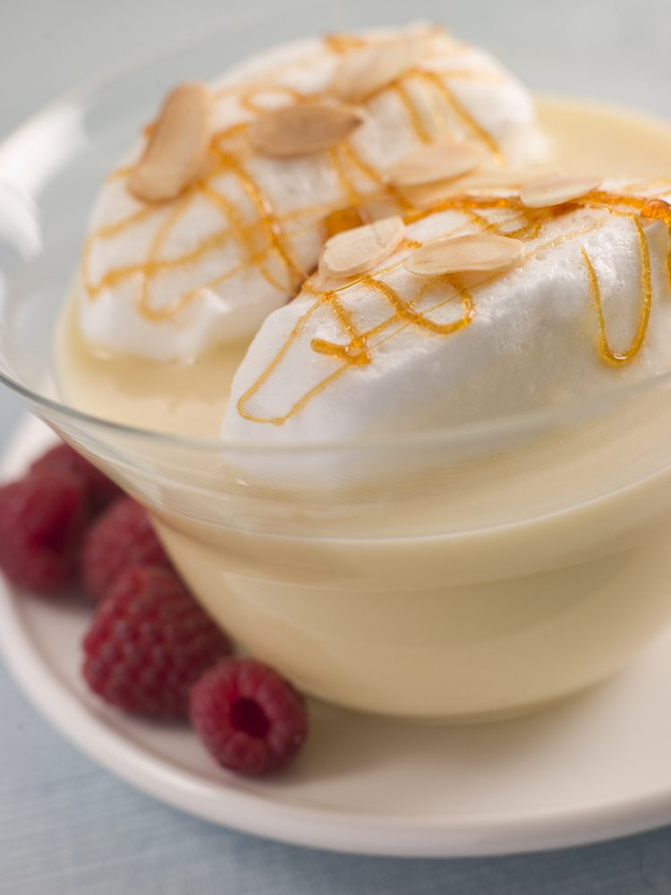
These ingredients are cooked over a bain-marie until the custard thickens sufficiently to coat a spoon (82ºC).
Anglaise is also used as a base for
- Bavarian cream or bavarois
- Mousses, other than chocolate and
- Can be used as a sauce by itself.
Crème Brulee is a variation of and Anglaise but will use cream rather than milk.
It is important not to overheat and coagulate the eggs when making an Anglaise.
This mixture is then chilled, placed in an ice cream freezer together with the desired flavourings and the mixture is frozen to a temperature of -18ºC while being churned to incorporate air and produce the desired texture.
The result should be smooth, airy and creamy.

Ice cream must contain no less than 10% milk fat (butterfat) and must have at least 20 % MSNF (milk solids no fat).
A good quality ice cream should have a minimum of 40% total solids (fat, sweeteners and MSNF). Milk solids contribute to the whipping capability of the custard, however if the custard has a percentage too high in milk solids without enough fat from the egg yolks to balance, the lactose can crystallise, making the custard feel gritty.
Italian style gelato is made using whole milk (no cream) and a larger proportion of egg yolks. This gives the gelato its distinctive dense texture and intense flavour.
Soft serve ice cream is a low fat milk, sugar and stabilizer mixture, which is usually frozen by the retailer to order.

To produce soft serve ice cream a special soft serve freezer is required. This sort of Ice Cream is mostly consumed as a Sundae or other ice cream coupes or served in a cone. It has become a very popular children’s dessert within family restaurants and fast food chains.
Sorbets
There is often confusion between sorbets, (which are also called fruit ices or water ices) and sherbets.
A classic sorbet never contains milk, cream or egg.
In some sorbet recipes, a very small amount of lightly beaten egg white or Italian meringue is added during the churning process to lighten the texture and increase the yield:
- Sorbets are made from a wide variety of fruit juices or purees.
Recently, the addition of spices and herbs such as thyme, rosemary and basil have been popularised be some adventurous chefs, along with savoury sorbet variations made from tomato and cucumber and served as a refreshing first course or used as a palate cleanser between courses:
- The level of sweetness for a sorbet depends on its use.
The proper level of sweetness is determined by the addition of water or sugar syrup to the liquid or fruit juice.
This is most easily done using a sugar density meter:
- Brix scale uses refractrometer
- Baume scale uses a hydrometer, which is called a saccharometer.
Both measure the sugar content in a liquid.
If it is served for a dessert or as a component thereof, it is usually quite sweet with a Baume between 16˚ and 20˚. If the sorbet is used as a cleanser or between courses, it will usually have a Baume of 12˚.
Sherbets, although close to sorbets in character, are always served as a dessert.
They contain milk or cream and sometimes a small amount of egg, giving them a smoother, richer texture than sorbets.

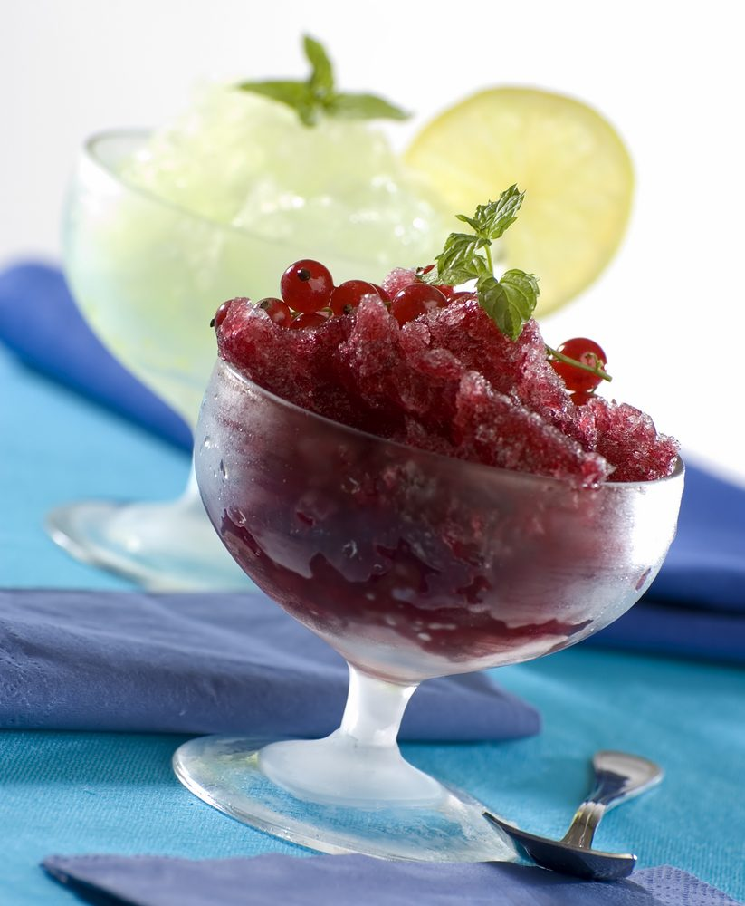
Granita and Granitée
These are the Italian and French names respectively for a type of coarse dessert ice.
They use basically the same ingredients as sorbets; however they have lower sugar content and are frozen with or without churning.
They are made by combining simple syrup or water with various fruit purees, liqueurs, wines, brewed coffee or tea.
The Baume level is between 8ºC and 12ºC.
Without churning, the mixture is frozen in a shallow pan, preferably stainless steel.
The base is stirred from time to time as it hardens in the freezer. The mixture is then scraped into flakes at serving time.
The alternative to creating a granita by hand would be to purchase a commercial churning machine.

Soufflé Glace
Soufflé glace or frozen soufflés have Italian meringue folded through a parfait or bombe mixture to imitate the lightness found in a hot soufflé. This can be flavoured with liqueur or fruit.
The filling is then filled high above the rim of a soufflé mould, frozen, and served in that form.

Frozen Mousses
These are closely related to both parfaits and soufflé glace. Although each of these desserts is classically made using a different formula, they share common characteristics:
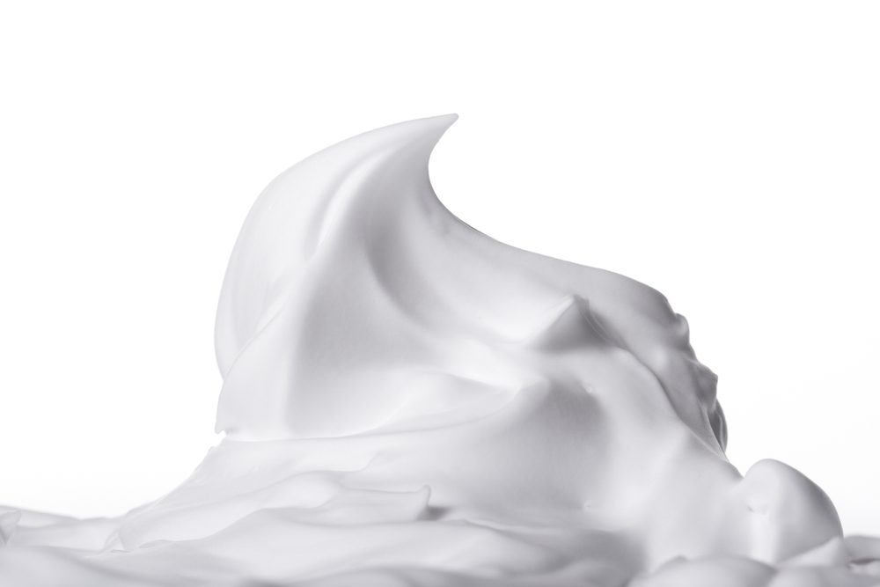
- All achieve volume from air that is whipped into cream, eggs or meringue
- All are frozen without churning
- All require little or no stabilisers such as gelatine or pectin.
A frozen mousse is distinguished from a parfait as it includes whipped egg white which is never used in a true classical parfait mixture.

Hygiene
Ice-cream is the perfect breeding ground for bacteria, so care must be taken throughout the making and storage of ice-cream, and also the cleaning of the equipment.
All components of the ice-cream machine need to be thoroughly cleaned and sanitised after use.
NB: Ice-cream should never be thawed and re-churned as this is ideal for bacterial growth.
Ice-cream that is partly thawed and re-frozen is not only a potential for bacteria to breed, it will also result in a product that is hard and icy. This practice is illegal!

Storage
Place frozen churned ice-cream into a freezer at -18ºC until frozen, then store at -15°C to -9°C.
Ideally ice-cream should be served at a higher temperature as it is softer and easier to scoop, and more flavoursome and enjoyable to eat.
All iced products should be stored in a clean, stainless steel container with a tight fitting lid.
A cartouche of silicon paper can be placed on the surface of the iced product to prevent ice crystals forming on the surface.
Avoid placing cling film directly on the surface of the soft ice cream, as when it freezes often cling film will remain on the surface and can become part of the ice cream mixture.
This only results in customers eating ice cream garnished with pieces of plastic in their food.

Ingredients affecting the texture of Ice-Cream
The ideal eating quality of ice-cream should be that it is smooth, rich and creamy in texture. In order to produce these qualities we must take the following into consideration.
Ingredients
Excessive Amounts of:
Sugars | Inhibits freezing. Too much sugar and the product will be too sweet to eat and will not set.
Fats | Too much fat and the product will be grainy and soft in texture and will leave a film of fat in the mouth.
Alcohol | Inhibits freezing. Alcohol does not freeze, and the end product will be softer and the flavour can be too strong.
Insufficient Amounts of:
Sugars and Fats – can result in an icy, coarse texture

Factors affecting the texture of Ice-Cream
- Rate of freezing – Fast freezing produces small crystals resulting in a product that is smooth. In contrast, ice-cream that is frozen too slowly allows the ice-cream to soften or melt. This results in ice crystals forming giving an icy and grainy texture
- Agitation – Churning in an ice-cream machine keeps the ice crystals small, resulting in a smooth product. However excessive churning can split the mixture.
Stabiliser
Commercial brands of ice-cream use a stabiliser which gives the product a longer shelf life and a softer product that is easier to scoop.
These stabilisers are often gelatine or vegetable based and include Seed Gums, Seaweed extracts, Pectin and Cellulose derivatives.
Flavour
In production of ice-cream, the flavours need to be considered.
Because flavours dull when frozen it is critical that the flavour in production is strong enough to offset this effect. This will ensure a well flavoured end product.
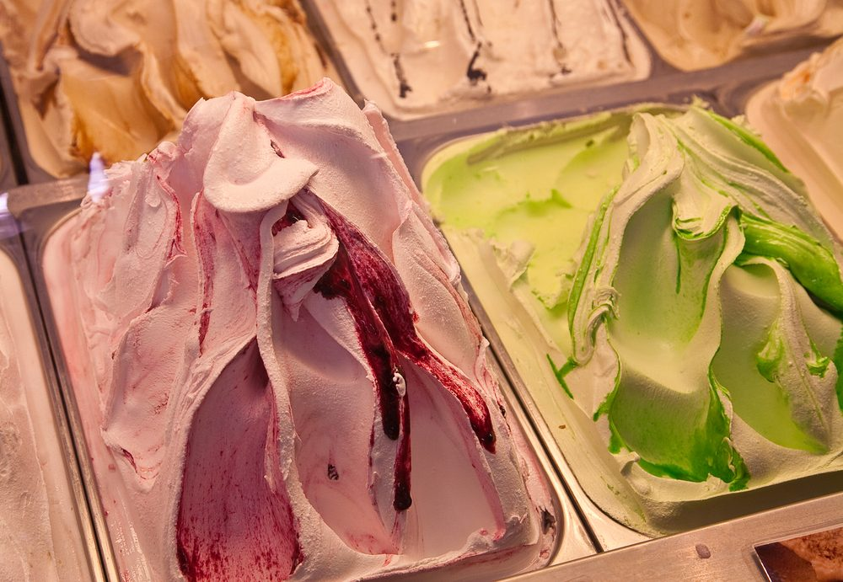

1.5 Use appropriate equipment to prepare hot, cold and frozen desserts
Equipment may include:
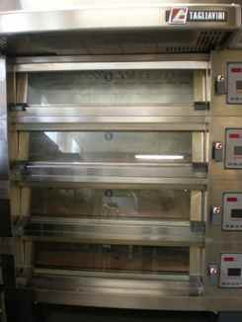 | 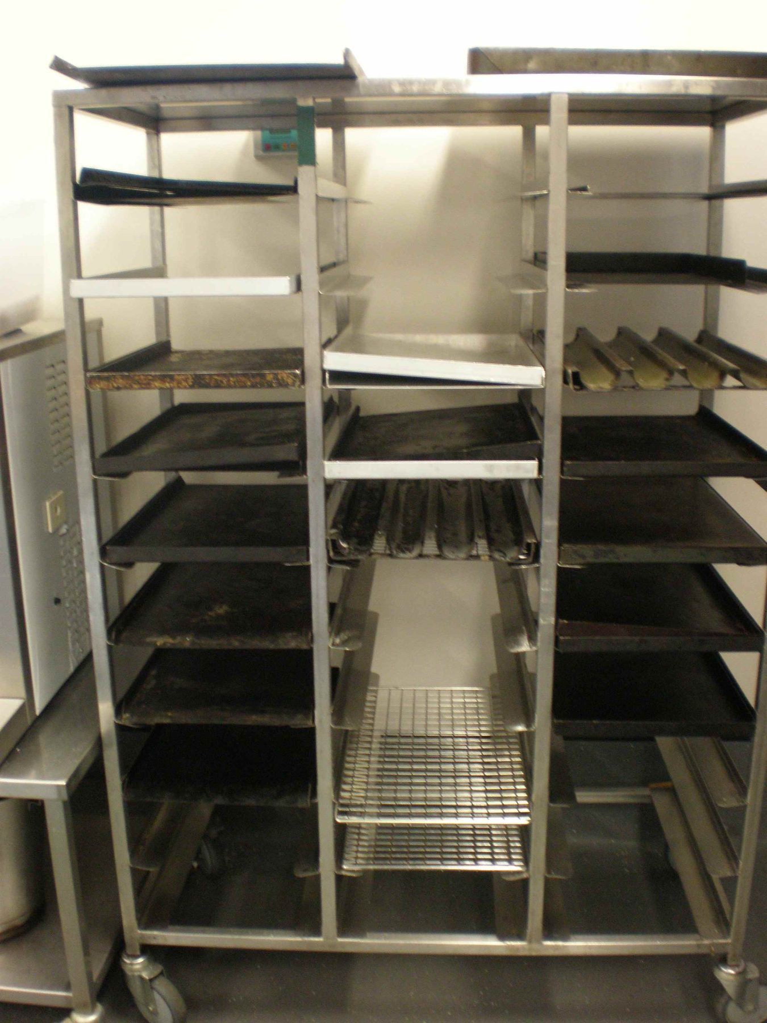
Ovens | Trays
 | 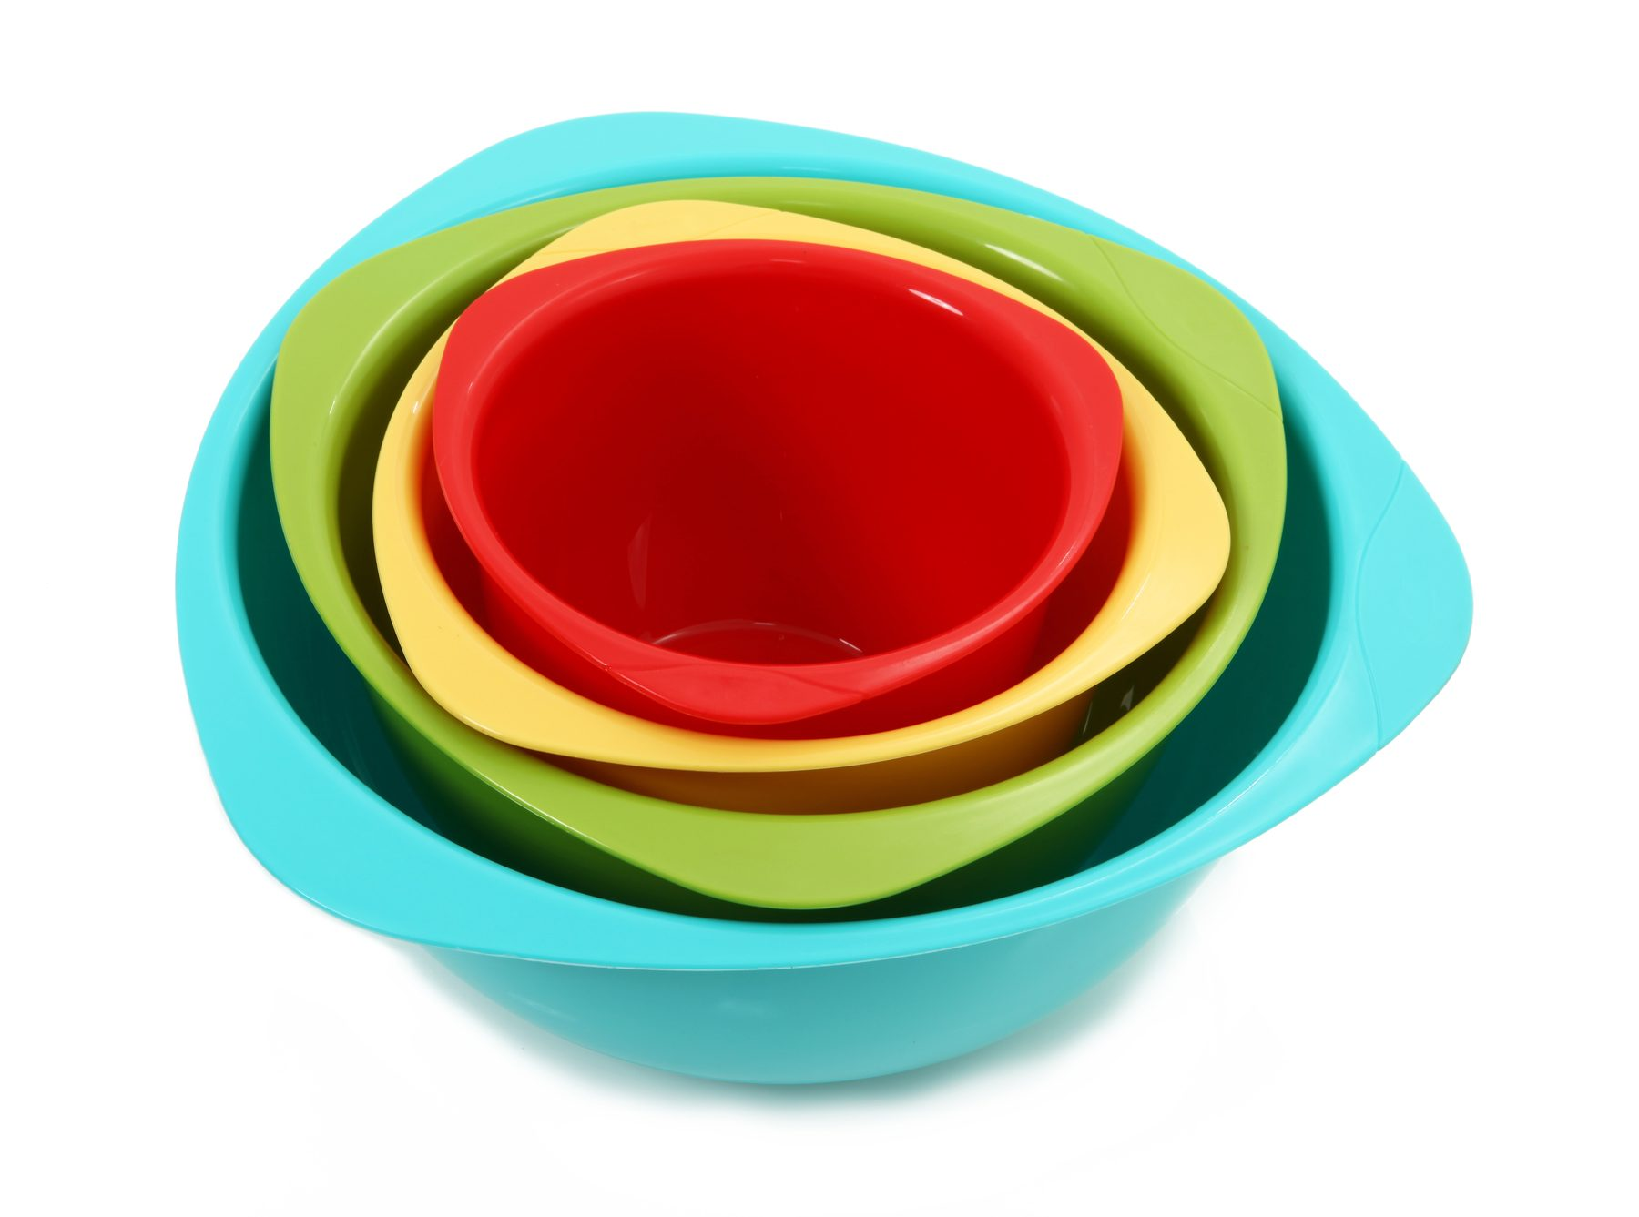
Racks | Bowls
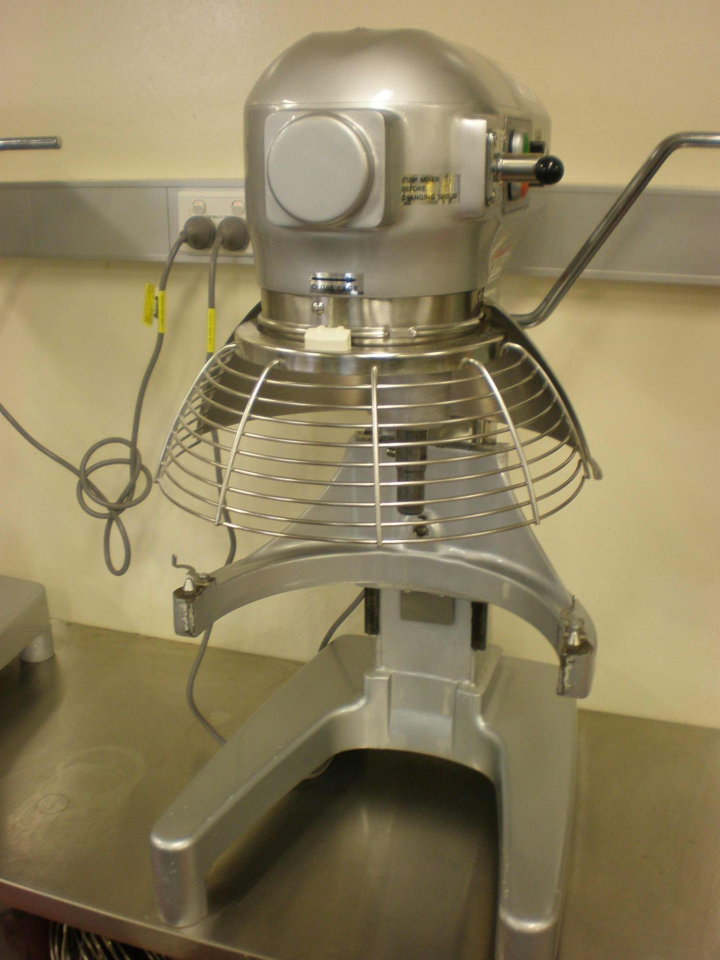 | 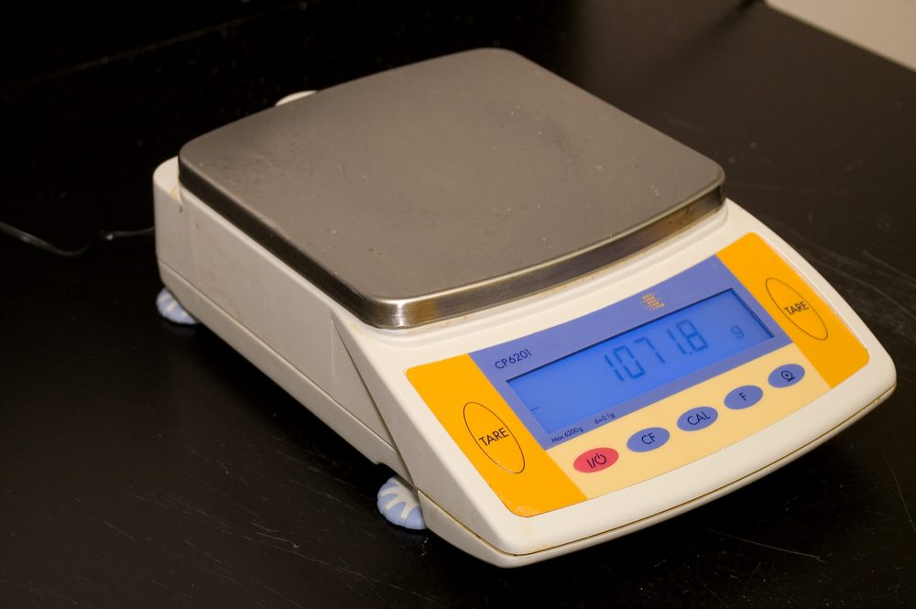
Mixing machine | Scales

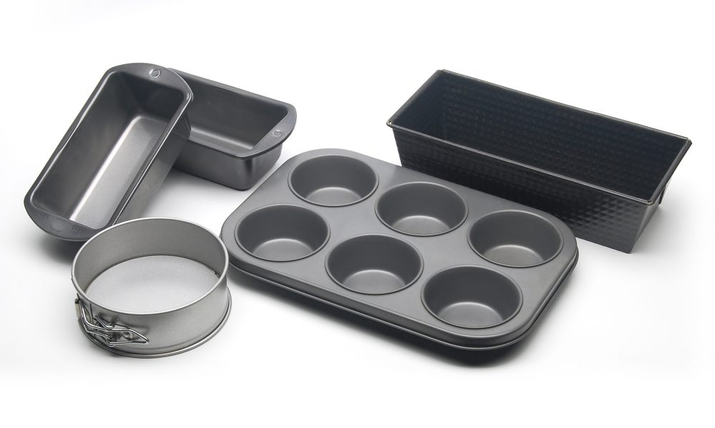 | 
Rings, tins and moulds | Fridge and freezer
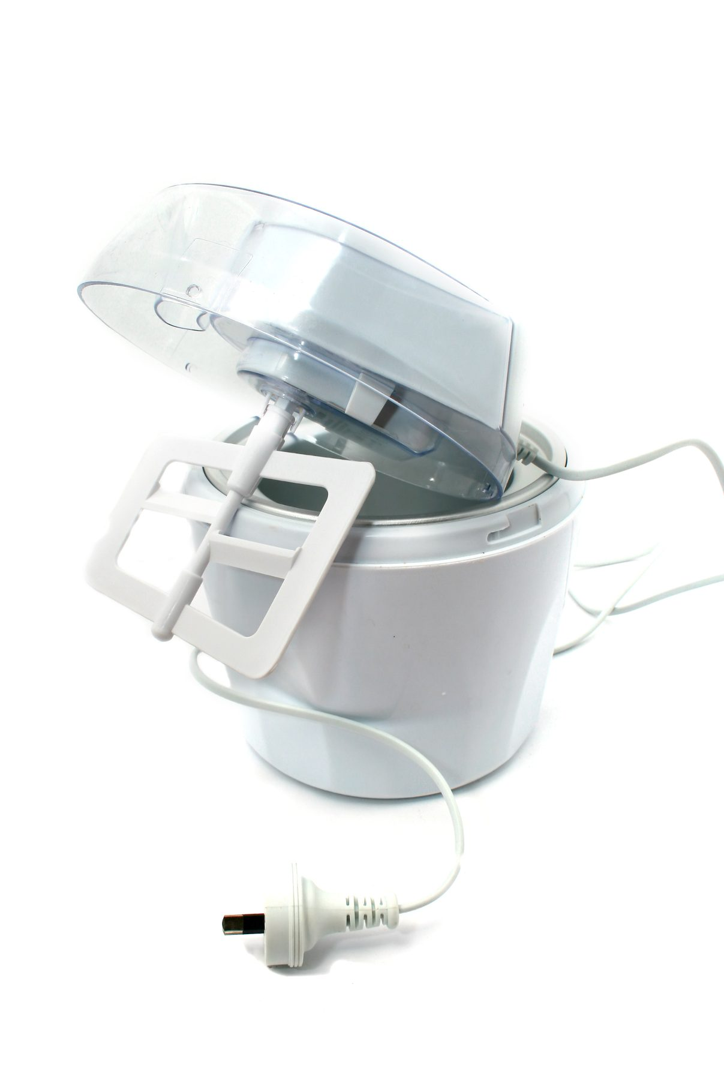 | 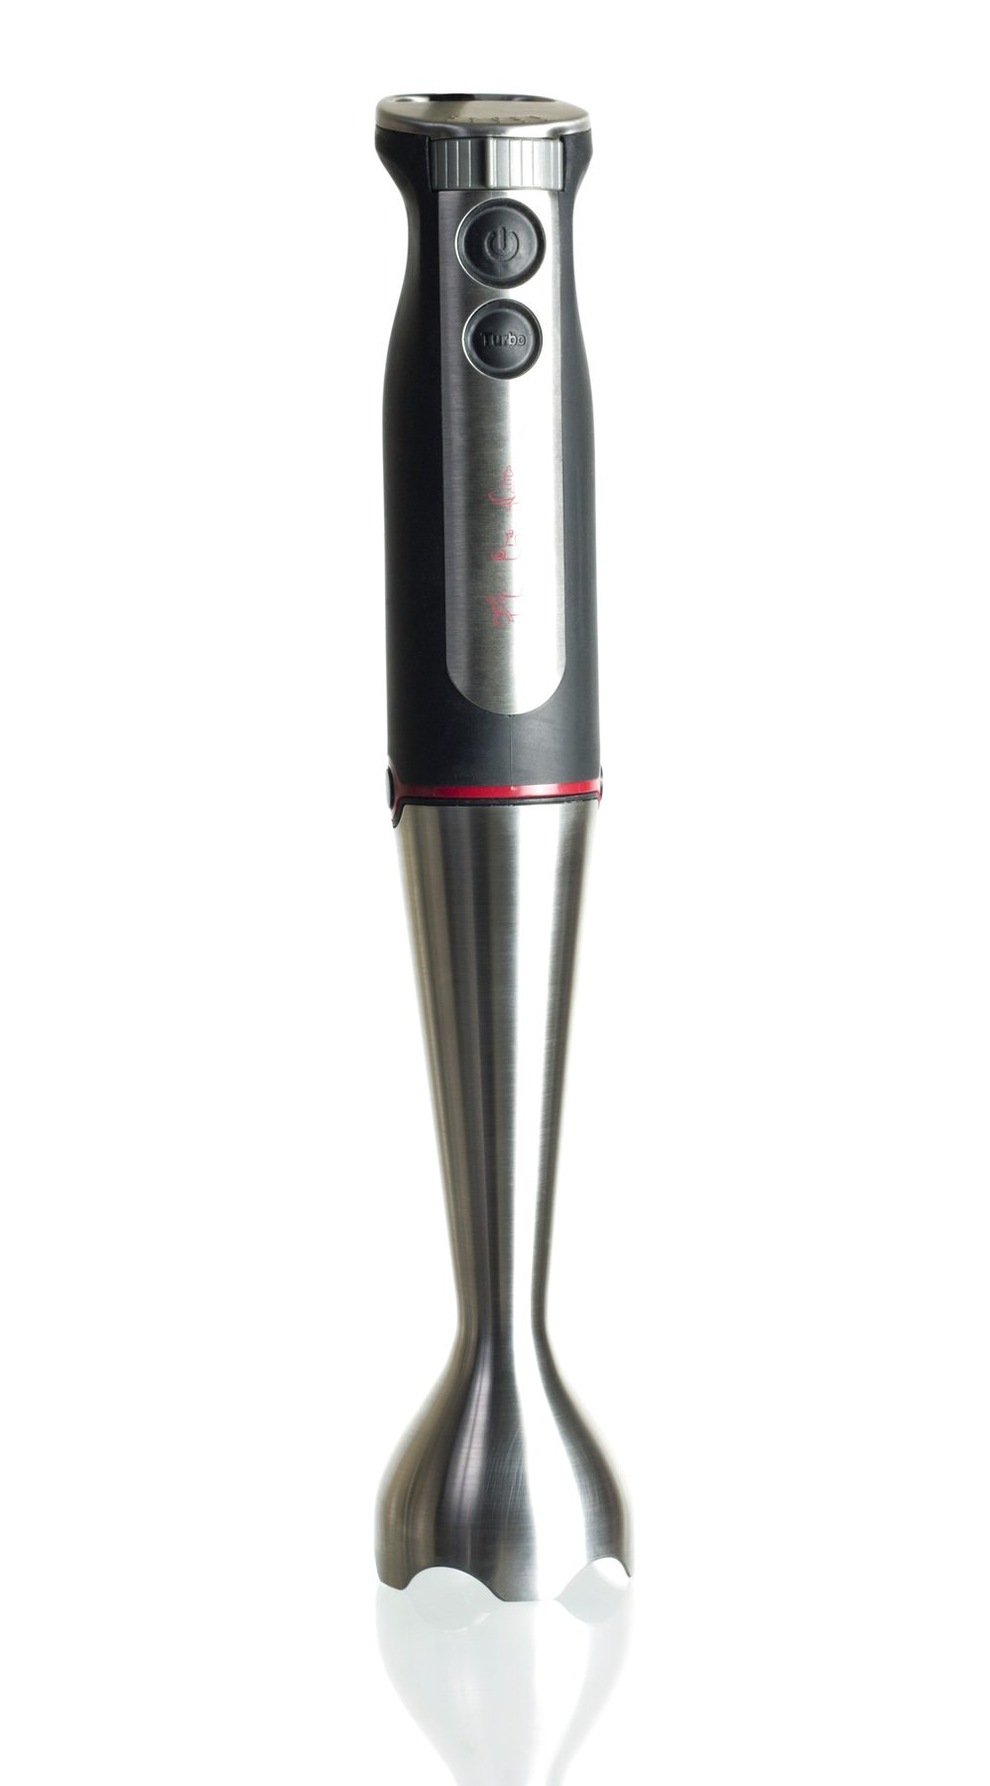
Ice cream machine | Blenders
Desserts production is an amalgam of many skills.
Proficient production relies on the pastrycook’s ability to work across a range of equipment.
To operate machinery correctly needs to be adhered to if good production is to be achieved.
Manual handling of trays and equipment can cause physical harm is precautions are not followed.
Fridges and freezers need to be kept clean and in good working order
Ice cream machines need to be scrupulously clean
Blenders also need to be scrupulously clean and blades must be kept sharp.

1.6 Use correct techniques to produce hot, cold and frozen desserts to enterprise standards

Techniques used to produce quality hot and cold desserts
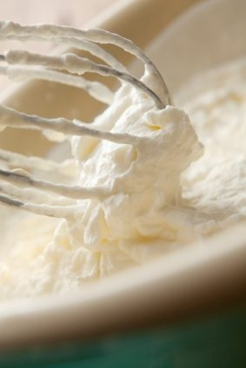
Beating
Mixing vigorously to incorporate air into an ingredient or mixture
Whisking
Using a whisk to incorporate air into liquids like cream and egg whites into meringues
Folding
Gentle movement that incorporates one product into another:
- Fold nuts into cream
- Fold sugar into meringue.
Baking
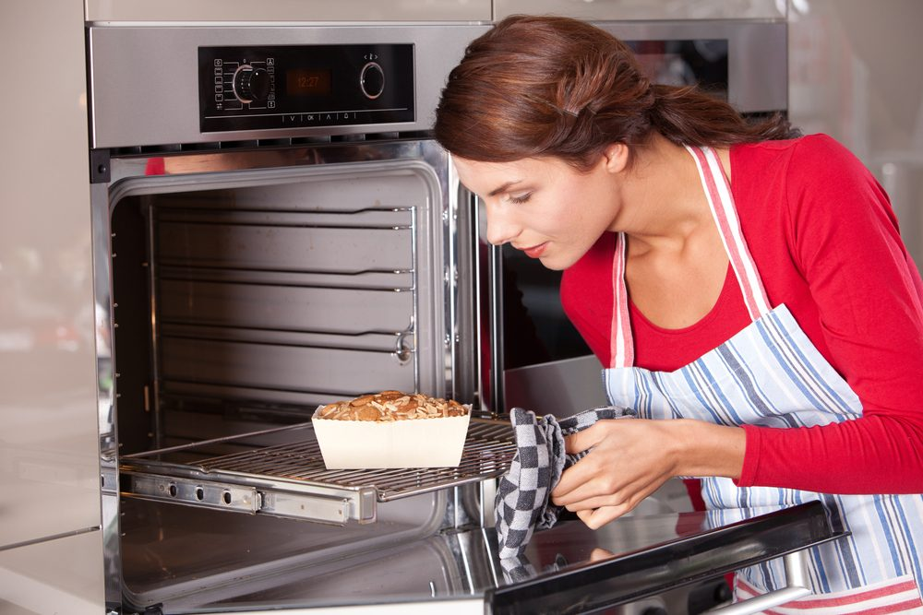
Subjecting unbaked product to heat in an enclosed area such as an oven
Whipping
Same as whisking
Blending
Combining two or more ingredients
Boiling
Subjecting food to heat while being completely submerged in liquid
Poaching
Subjecting food to heat in liquid that is hot, but not moving; food needs to be totally submerged at a temperature of 90°C to 93°C
Steaming
Subjecting food to heat in vapour of boiling liquid from below
Enrobing
Completely covering product; pouring ganache over the top, allowing ganache to flow down the side to completely cover the cake; to dip in chocolate to completely cover all sides.

Churning
Continual mixing of a liquid until an outcome is achieved
- Mixing cream in container until all fat molecules are compacted and butter has formed.
- Butter is churned further to remove as much water as possible
- Churning and chilling Anglaise until enough air is incorporated to reach the consistency good ice cream.

1.7 Produce hot, cold and frozen desserts to enterprise requirements and standards
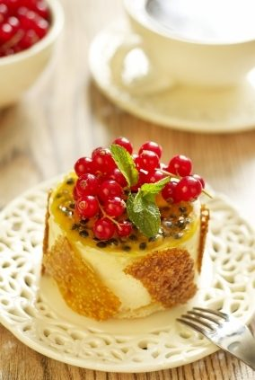
Enterprise requirements and standards should relate to:
- Scale to correct weight
- Colour
- Consistency
- Texture
- Moisture
- Mouth feel
- Appearance
- Saleability.
All product standards can be interpreted differently depending on their place of sale.
No matter how the interpretation is displayed consistency will still be the key:
- All need to be the same size
- They must have the colour characteristic to that product
- Is the colour natural or artificial?
Texture, moisture and mouth feel all come together in the product and that is what makes the product stand out above the rest:
- Appearance must be appealing to the eye of the customer.
All this adds to the saleability of the product.
Products can be made with artificial colours and flavourings and can still be classified as a good quality product:
- Some people just go by the look of the product
- Some are judged on the quality of ingredients and the look is secondary.
- Quality is very definitive but can be allusive as well.
- Standards vary as well.

Food Safety Standards must not vary. Same standards apply for the best quality ingredients as they do for the more budget ingredients
Standards and Quality
Standards and quality can relate to ingredients such as:
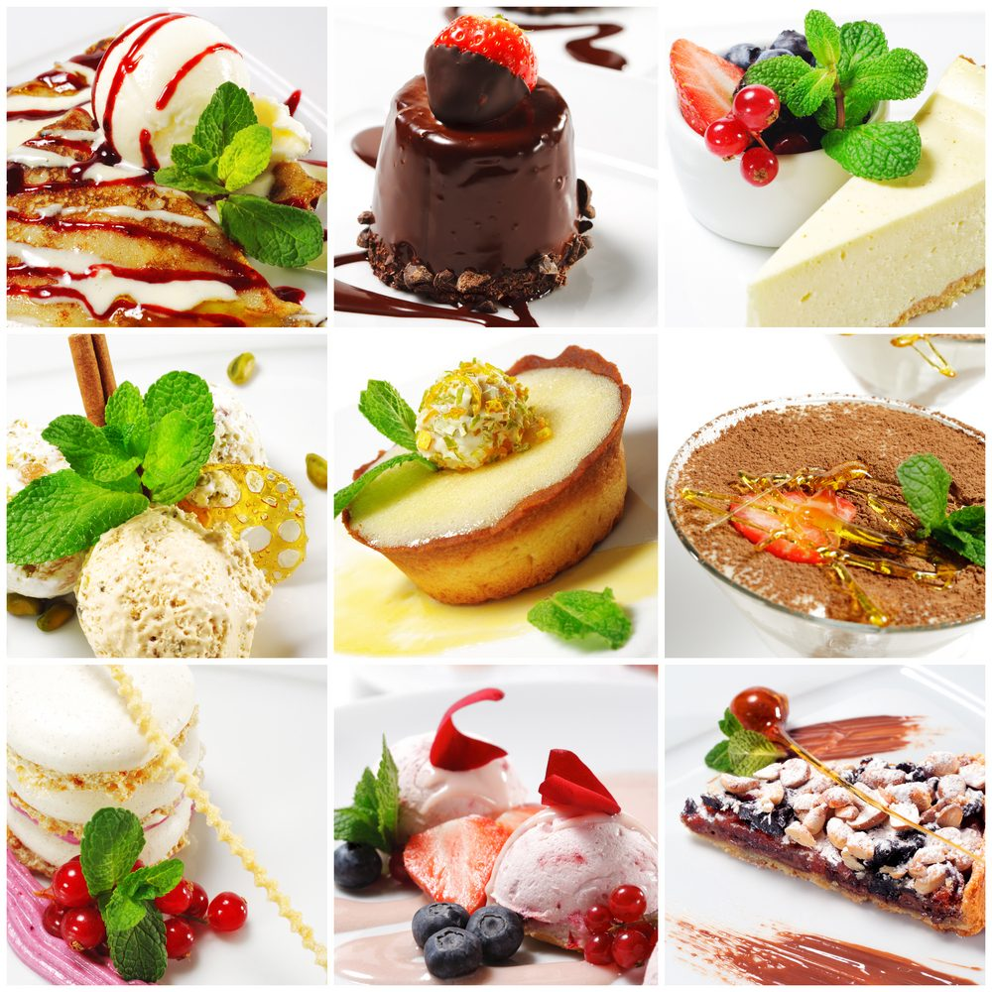
- Flavouring
- Colouring
- Quality.
Does the product need pink colour to make the strawberry ice cream look pink?
- When fresh strawberries are used in ice cream the colour can be close to grey
- Doe the recipe call for chocolate flavour
- Bakers chocolate
- Couverture
- Cocoa powder:
- Alkaline treated or non alkaline treated.
Is the dark brown colour from the colour of the cocoa or has there been the addition of a brown colour to make it appear darker?
- Chocolate flavoured can appear darker with the addition of red colour to the ingredients.
Quality is difficult to define
- Is it based on price the price of ingredients used to make a product?
- Is it based on the level of income earned from selling the product?
'Consistency' is the one main key to quality:
- Is the product the same every time it is produced
- Ingredients the same?
- Do they look the same?
- Are they the same weight and shape
- Is the same number of units obtained from the same recipe each time?
- Is the time spent manufacturing the product the same every time?
These are all questions that needs to be answered when it comes to Quality of the Product.
It is not just the value of the ingredients that are used or where it is sold.
- Each enterprises standards and quality will vary
- Each enterprise will have different requirements.

1.8 Select correct cooking conditions for hot, cold and frozen desserts
Desserts are an amalgam of skills:
- Baking | - Poaching
- Whipping | - Steaming
- Blending | - Enrobing
- Boiling | - Churning.
Ice cream is a frozen product but it must be cooked:
- The base sauce, Anglaise, is boiled milk and sugar thickened with eggs
- The base sauce is then flavoured.
Cream can be added and then this mixture is churned and chilled incorporating air into the mixture to form the concoction we all delight in eating; Ice Cream.
Cake can be steamed and served as puddings rather than being baked.
Competent pastrycooks are able to adapt many variations to produce desserts but need to master the basic skills to increase their repertoire of desserts.
Some products may require specific conditions to be applied during the process that cannot be hurried.
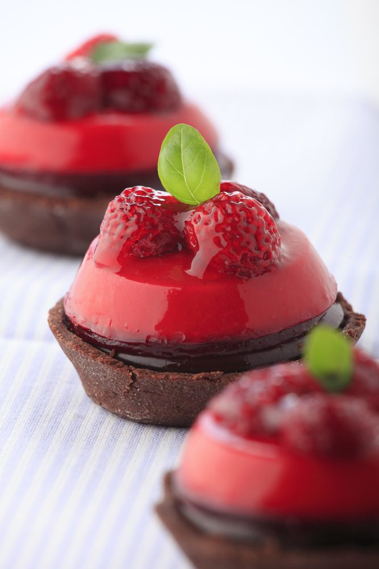
Apply conditions during the process
- Product needs to sit on baking tray 40 minutes before baking:
- This is a step in the process of making French macaroons.
- Egg whites almonds and sugar
- There is a specific look that these pastries have
- Nice clear smooth dome with a clean break around the bottom of each piece:
- The product is required to rest and be air dried for this to happen
- The surface of the meringue dries and when the product bakes in the oven it will rise when exposed to the oven heat
- The product should break at the weakest point; that is where the product meets the tray; this is the last place to dry
- When product is removed from the oven the 'dome' should be intact and the 'crack' should appear around the base
- Many products have these needs for conditions to be applied.
- Understanding why is part of the skill of producing a quality product each time.

Work Projects
It is a requirement of this Unit you complete Work Projects as advised by your Trainer.
You must submit documentation, suitable evidence or other relevant proof of completion of the project by the agreed date with your Trainer.
Student will need to be able to demonstrate competency by demonstrating ability to produce a wide of desserts.
Suggested desserts may be:
- Baked Sweet Soufflé
- French crepes with cooked fruit filling complimented with a sauce
- Baked egg custard like crème caramel
- Variety of sauces both cooked Anglaise sauce and fruit coulis
- Iced soufflé
- Set creams like flavoured Bavarian creams and flavoured mousses
- Meringue based desserts like Pavlova or Japonaise
- Fruit pies or cobblers served with flavoured starch thickened sauce
- Ice cream served with a quick bread such as pancake.
Working with your trainer you will need to be able to produce a variety of desserts.
Plan the desserts to meet following stages. A report or work plan will need to be prepared before you start.
The report will show the sequence of production and all commodities and equipment that will be required to produce the selected desserts.
1.1 Select all ingredients required.
1.2. Prepare 2 varieties of hot desserts of 2 serve from each recipe.
1.3. Prepare 2 varieties of cold desserts of 2 serve from each recipe.
1.4. Prepare 1 of frozen dessert of 2 serve from each recipe.
1.5 List of all equipment required to produce each dessert.

Summary

Prepare and produce a range of hot, cold and frozen desserts
Select commodities required
Here it is not about flour sugar to make the sponge but it is just the sponge that is required
Not egg white and sugar but meringue
The preparation hot, cold and frozen desserts is about an amalgam of knowledge and skills. Commodities will be a produced by adding product to simple ingredients like cream and sugar.
Prepare a variety of desserts according to standard recipe and enterprise standards
Hot, cold or frozen. Each recipe will yield an amount or number of portions.
Use correct equipment
Interpreting the recipe before staring will determine the required equipment.
Use correct technique
Produce to enterprise standards
Size and the look required will differ at each establishment but a chocolate mousse still needs to be a chocolate mousse
Select correct cooking conditions for hot cold and frozen desserts
Baked
Boiled
Poached
Steamed.
Desserts are an amalgam of skills and techniques combined to produce classic dessert to the enterprise standards and requirements.

Element 2:
Prepare and store sweet sauces

2.1 Select required commodities according to recipe and production requirements
Commodities for sweet sauces
Sugars
Sugar is used in dessert production to:
- Add sweetness and flavour
- Create tenderness and fineness of texture, partly by weakening the gluten structure
- Give crust colour
- Increase keeping qualities by retaining moisture (it is a humectant)
- Act as a creaming agents with fats and as foaming agents with eggs
- Provide food for yeast
- To preserve.
Refined sugars are classified by the size of the grains.
Caster Sugar in finer than regular granulated sugar. This sugar supports higher quantities of fat and dissolves relatively quickly into doughs and batters.
Caster sugar is the premium sugar to use in production of quality desserts and pastries.

Regular Granulated Sugar also known as table sugar or A1 is the most commonly known sugar.
Brown Sugar contains 85 – 92 % sucrose and varying amounts of caramel, molasses and other impurities. Darker grades contain more of these impurities. Brown sugar is regular cane sugar that has not been completely refined
Demererra Sugar is also known as raw sugar. These straw coloured granules are produced from cane juice (90% sucrose). They are used in some baked goods and hot beverages.
Icing Sugar also known as confectioner’s sugar, is sugar ground to a fine powder.
Soft Icing Mixture is icing sugar mixed with a small amount of starch (3 %) to prevent caking. It is also available in a pure form without this anti-caking starch.
Invert Sugar is a product of sugar refining. It is chemically processed heavy syrup where a sucrose solution is heated with an acid.

The sucrose breaks down into two simple sugars, dextrose and levulose:
DEXTROSE + LEVULOSE = INVERT SUGAR
(Equal parts)
Invert sugar is 30 % sweeter than sucrose.
Invert sugar resists crystallisation, promoting smoothness in candies, icings and syrups. It also holds moisture especially well, retaining freshness and moisture in products.
Molasses is concentrated sugar cane juice. It contains large amounts of sucrose and other sugars including invert sugar. It also contains acids, moisture and other constituents that give it flavour and colour. Darker grades are stronger in flavour and contain less sugar than lighter grades. Molasses retains moisture in baked goods, prolonging their freshness.
Corn Syrup is a liquid sweetener consisting of water, a vegetable gum called dextrin and various sugars, primarily dextrose, also called glucose. Corn syrup is made by converting cornstarch into simpler compounds through the use of enzymes. Corn syrup aids in retaining moisture and is used in some icings, sweets, and sugar boiling. It keeps other sugars from recrystallising. It is added to marzipan to improve elasticity. It has a mild flavour and is not as sweet as sucrose.
Glucose Syrup is viscous, colourless syrup (44˚ Baume). Glucose has a stabilising effect to help prevent re-crystallisation when sugar is boiled to high temperatures e.g. Cast, pulled and blown sugar making the boiled sugar more elastic. It is also used in cakes and biscuits. Glucose should not be stored at temperatures above 20ºC because it will change in colour. Glucose can be replaced with light corn syrup.

Honey was the first sugar to be used by man. It is the nectar collected from bees and deposited in their honeycomb. Nectar contains about 80% water and 20% sugar together with essential oils and aromatic compounds that are responsible for the bouquet of honey, the flavour varying from the flowers from which the nectar was gathered.
The darker the colour of the honey, the stronger its flavour; it is a natural sugar syrup consisting largely of glucose, fructose and other compounds that give it is flavours. Flavour is the main reason for using honey.
Honey contains invert sugar which helps retain moisture in baked goods and gives a soft chewy texture to cakes and cookies, and is baked at a lower temperature so the invert sugars can caramelise.
Honey contains acid which enables it to be used with baking soda as a leavening.
Honey is available as:
- Comb honey – still in its waxy capsules
- Chunk honey – contains both the filtered extracted honey and a piece of honeycomb
- Extracted honey – most familiar for cooking and table use.
Whipped or spun honey – extracted honey that is processed using controlled crystallisation and which has fine easily spreadable crystals.
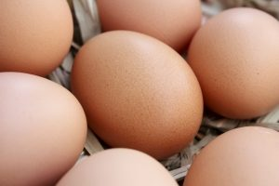
Eggs
Eggs are used to thicken milk or cream sauces, such as Crème Anglaise. As the mixture is heated the proteins unfurl and bond together. If it is over heated the proteins will break apart and re-curl causing the mixture to curdle.
Fruits
Fruits will often be cooked with sugar and pureed, and are usually sieved to remove seeds.
Starches
Starches are used to thicken sauces. They are added to liquids when cold and heated until the starch granules swell and absorb the liquid, holding suspension.
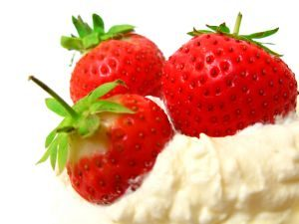
Creams
Creams can be eaten raw or cooked, whipped or un-whipped.
Cream is available in varying ‘fat’ contents:
- 45% is considered pure cream

- 35% with added vegetable gums; thickened cream; is the most common cream used in the kitchen. It can be cooked, whipped or served ‘au natural’ as a pouring cream.
Vegetable Gums
These are used in emulsions and sauces that are served cold or at room temperatures.
Butter
Unsalted butter can be used in sauces that are for desserts .

2.2 Prepare and produce a range of sweet sauces to enterprise requirements and standards

Sauces
Most desserts are served with a sweet sauce that compliments the dish.
Sauces can be served hot, warm or cold and use different methods of thickening such as:
- Fruit pectin – coulis or compote
- Egg yolk – Anglaise, sabayon
- Sugar (caramel) – syrup, butterscotch or caramel sauce
- Cornstarch or arrowroot – chocolate, lemon
- Fats – cream, chocolate
- Reduction – citrus juices
- Vegetable gums – added to liquids, thickening as mixtures chill.
Most desserts will always be accompanied by a sauce

